Integrate Zscaler with Identity Providers (IdPs)suchasAzureAD,Okta,andActive Directory for seamless authentication and authorization.

TEAM DETAILS

S.No | NAME | COLLEGE | CONTACT
1 | DIVYADHARSHINI S  (Team Leader) | United College of Arts and Science | dividivyadharshini8@gmail.com
2 | GOPAL D  (Team Leader) | United College of Arts and Science | gopalgopal06527@gmail.com
3 | EBINEZAR S  (Team member) | United College of Arts and Science | ebiebinezar00@gmail.com
4 | GOKUL S  (Team member) | United College of Arts and Science | gokulgokul2720@gmail.com

Projectdetails

Title:IntegrateZscalerwithIdentityProviders(IdPs)suchasAzureAD,Okta,and Active Directory for seamless authentication and authorization.

ThisprojectoutlinesthestrategyandimplementationplanforintegratingtheZscaler security platform with our organization's core Identity Providers (IdPs): Microsoft Entra ID (Azure AD), Okta, and on-premises Active Directory (AD). The primary objective is to create a seamless, secure, and automated framework for user authentication and authorization across all Zscaler services.

By moving away from disparate local user management and leveraging these centralized identity sources,we aim to establish atrue Zero Trust architecturewhere accessiscontinuouslyverifiedbasedonuseridentityandcontext.Thisinitiativewill consolidate authentication into a single source of truth, enforce consistent security policies like Multi-Factor Authentication (MFA), andstreamline the user experience through Single Sign-On (SSO).

Ultimately, this integration will serve as the critical link between our identity infrastructureandoursecurityenforcementpoint,ensuringthattherightusershavethe rightlevelofsecureaccesstotheinternetandapplications,regardlessoftheirlocation.

Abstract:
This project details the integration of the Zscaler Internet security platform with leadingIdentityProviders(IdPs),includingMicrosoftEntraID(AzureAD),Okta, and on-premises Active Directory (AD). The primary objective is to establish a unified identity framework that enables seamless Single Sign-On (SSO) and centralized authorization for all Zscaler services. By consolidating authentication into trusted corporate directories, this initiative eliminates the need for disparate credentials and provides a foundational element for a modernZero Trustsecurity architecture.
Byleveragingindustry-standardprotocolssuchasSAML,OIDC,andSCIM,this integration ensures that user authentication is delegated to trusted corporate directories while enforcing consistent security policies, including Multi-Factor Authentication (MFA). This approach not only enhances the user experience by reducingpasswordfatiguebutalsostrengthenstheorganization'ssecurityposture by ensuring that every access request is verified by the identity provider before reaching Zscaler's security enforcement points.
Furthermore, the implementation of automated user provisioning via SCIM streamlines lifecycle management, reducing administrative overhead and enhancing security posture. The outcome is a robust, identity-centric security modelthatalignswithZeroTrust principles,ensuringthatonlyauthenticatedand authorized users gain secure access to internet and cloud applications from any location.Thisintegrationeffectivelybridgesthegapbetweenidentitygovernance and network security, creating a dynamic and responsive access control environment.

UseCaseScenarios:

UseCaseScenario1:RemoteFacultyAccessto ResearchData
A research professor is working from an off-campus conference and needs secure access to sensitive research data stored on an internal server. Instead of connecting to the full campus network via VPN, ZPA grants access only to the specific research server. The professor authenticates via the university's identity provider, and access is granted based on their role.

Output:
- Useridentityverified:Research_Faculty_Group
- Context-awareaccessenforced:Accessallowedonlyfromnon-campus IP ranges
- Connectionrestricted: LimitedtospecificResearchFileServer(R&D_Server)
- Securityenforcement: Multi-FactorAuthentication(MFA)requiredduetooff-network location
- Nolateralmovement: UsercannotaccessotherinternalsystemssuchasHRorstudentrecords

UseCaseScenario2:StudentAccesstoLibraryResources
Agraduatestudentisoff-campusandneedsaccesstolicensedacademicjournalsanddatabases hosted internally. Instead of requiring a full VPN tunnel, ZPA provides direct access to the library application portal. The student authenticates via the identity provider, ensuring only enrolled students can access paid subscription content.

Output:
- Useridentityverified:Enrolled_Student_Group
- Accessscopedefined: LimitedtoLibraryPortalandjournal databases
- Policyenforcement:Accessrestrictedtoauthorizedusersonly,preventing credential sharing
- Userexperience:SeamlessSSOwithoutadditionalVPNclientcomplexity
- Nobroadnetworkaccess:Studentcannotnavigatetoadministrativesystemsorinternal servers

UseCaseScenario3:HRAdministratorAccesstoPayrollSystem
An HR administrator requires access to the payroll system to process monthly salaries. Access mustberestrictedtospecificworkhoursandrequirestep-upauthenticationduetothesensitivity of the data. The administrator authenticates via the identity provider, and ZPA enforces time- based and MFA policies.

Output:
- Useridentityverified:HR_Payroll_Group
- Time-basedrestrictionenforced: Accesspermitted onlyduringbusinesshours(8:00AM–
6:00 PM)
- Step-upauthentication:MFAtriggereduponaccessingthepayrollapplication
- Connectionrestricted:Limited toPayrollApplicationServer
- Audittrail:Fullsessionloggingmaintainedforcompliancepurposes

UseCaseScenario4: ITHelpdeskRemote Troubleshooting
An IT support technician needs to remotely troubleshoot a server issue while working from home.ZPAprovidesJust-in-Time(JIT)accesstothespecificserverrequiringmaintenance.The technicianauthenticatesviatheidentityprovider,andadministrativeprivilegesaregrantedonly for the duration of the task.

Output:
- Useridentityverified:IT_Helpdesk_Group
- Just-in-Timeaccessgranted: Adminrightselevatedonlyfortheactive session
- Connectionrestricted: Limitedtothespecifictargetserver (Server-X)
- Privilegeboundariesenforced:Noaccesstootherinfrastructurecomponents(databases, domain controllers)
- Sessionmonitoring:Real-timeactivityloggingforsecurityreview

UseCaseScenario5:ContractorAccesstoProjectManagementTool
An external project manager contracted for a specific initiative needs access to the university's project management tool (e.g., Jira or SharePoint). Access must expire automatically upon contractcompletion.Thecontractorauthenticatesviatheidentityprovider,andZPAprovisions time-limited access based on group membership synchronized from Azure AD.

Output:
- Useridentityverified:External_Contractor_Group
- Time-boundaccesspolicyenforced:Accountdeprovisionedautomaticallyaftercontractend date
- Connectionrestricted: LimitedtoProjectManagementApplicationonly
- Segmentationenforced:Contractorcannotdiscoveroraccessinternalresourceslikefinance systems or student databases

Stage-1

TitleOf theProject:-

ReplaceandmodernizelegacyVPNarchitectureswithacloud-nativeZscalerZeroTrust solution to reduce attack surface and lateral movement.

Overview: -

TheintegrationofZscalerwithenterpriseIdentityProviders(IdPs)representsafundamentalshift in how organizations approach secure access to applications and resources. Traditional network security models relied on VPNs and perimeter-based defenses, which often granted excessive accessandcreatedlateralmovementrisks.Bycontrast,thisprojectleveragesZscaler'sZeroTrust Exchange platform to verify identity at the application layer rather than the network layer. The integrationwithleadingIdPssuchasMicrosoftEntraID,Okta,andon-premisesActiveDirectory establishes a unified identity fabric across the organization. This ensures that users are authenticated consistently regardless of their location or device. The project eliminates the need forduplicateuserdirectoriesandmanualaccountmanagementwithinZscaler.Itcreatesaseamless experiencewhereusersauthenticateonceandgainaccesstoauthorizedresources.Securityteams benefit from centralized control over authentication policies and user lifecycle management. The integration supports modern authentication standards including SAML, OIDC, and SCIM protocols.Ultimately,thisfoundationenablestrueZeroTrustsecuritywhereidentitybecomesthe primary control plane.
Microsoft Entra ID integration serves as a cornerstone of this identity strategy for organizations heavily invested in the Microsoft ecosystem. The integration leverages SAML 2.0 to establish federated trust between Zscaler and Azure AD for seamless Single Sign-On. Users accessing Zscaler Internet Access or Zscaler Private Access portals are redirected to Azure AD for authentication.ThisallowsorganizationstoenforceAzureADConditionalAccesspoliciesduring the authentication flow. Policies can require compliant devices, specific locations, or risk-based access controls before granting access to Zscaler. The integration extends beyond authentication to include automated user provisioning via the SCIM protocol. User accounts and group membershipsaresynchronizedinreal-timefromAzureADtoZscaler.Thisautomationeliminates manual provisioning errors and ensures immediate deprovisioning when users leave the organization. Azure AD's extensive reporting and auditing capabilities provide visibility into authentication attempts. The result is a tightly integrated security posture that leverages Microsoft's identity capabilities to protect Zscaler-enforced resources.
Okta integration provides a flexible and vendor-agnostic approach to identity management for Zscalerdeployments.AsaleadingindependentIdentityProvider,OktaconnectsZscalertoawide ecosystem of applications and directories. The integration utilizes OpenID Connect (OIDC) for modern,API-friendlyauthenticationtoZscalerservices.Thisapproachsupportsrichusercontext

including profile attributes and group memberships for policy enforcement. Okta's Universal Directory serves as the authoritative source for user identities synchronized from various HR systems and directories. The Okta Integration Network (OIN) simplifies setup with pre-built connectors and configuration guides for Zscaler. Automated provisioning via SCIM ensures that user changes in Okta are reflected in Zscaler within minutes. Lifecycle management events such as user onboarding, role changes, and terminations trigger automatic updates in Zscaler. Okta's adaptive MFA policies add an additional security layer during Zscaler authentication requests. This integration delivers a seamless experience for users while providing administrators with centralized identity governance across all Zscaler services.
On-premises Active Directory integration addresses scenarios where organizations are not ready forfull cloudidentitymigration.Manyinstitutionsmaintainextensiveon-premisesinfrastructure with complex group policies and nested organizational units. The Zscaler Authentication Bridge (ZAB)enablessecureLDAPcommunicationbetweenZscalercloudservicesandon-premisesAD. ThislightweightconnectorsitsbehindthefirewallandinitiatesoutboundconnectionstoZscaler, eliminatingtheneedforinbound firewallrules.Userauthenticationrequestsaresecurelyproxied through ZAB to validate credentials against the on-premises domain controllers. Group membership information is synchronized to Zscaler for use in policy definitions and access decisions. This approach preserves investments in existing Active Directory infrastructure while enablingcloud-delivered security.Organizations canmaintain strict accesscontrolsbasedon on- premises group memberships and organizational hierarchies.

ListofVulnerabilityTable:

PracticeWebsite:

S.no | VulnerabilityName | CWE -No
1 | ImproperSanitizationofFilePaths | CWE-284:Improper Access  Control
2 | InvalidCertificate | CWE-395: Improper  CertificateValidation
3 | MissingX-Frame-OptionsHeader | CWE-1021: Design ImproperRestrictionof  RenderedUILayersor Frames
4 | X-Content-TypeOptionsHeaderMissing | CWE-918:Server-Side  RequestForgery(SSRF)
5 | DrupalAjaxAPIshowsJSONPnotdisabledby default | CWE-937,1035:OWASP  TopTen2013,2017Category A9-UsingComponentswith Known Vulnerabilities

6 | DrupalApiVulnerability | CWE-20:Improper Input  Validation
7 | ImproperAPIFiltration | CWE-79: Improper Neutralisation of Input DuringWebPageGeneration  ('Cross-siteScripting')
8 | DenialofService | CWE-400:Uncontrolled  ResourceConsumption
9 | TLSVersion1.0Protocol Detection | CWE-327:Useofa Broken  orRiskyCryptographic Algorithm
10 | web.configFileInformationDisclosure | CWE-497: Exposure of SensitiveSystemInformation to an Unauthorised Control  Sphere

Main Website:

S.no | VulnerabilityName | CWE -No
1 | SLMediumStrengthCipherSuitesSupported (SWEET32) | CWE-200:Exposureof  SensitiveInformationtoan Unauthorised Actor
2 | CookieSERVERIDcreatedwithoutsecureflag | CWE-79: Improper  NeutralisationofInputDuring Web Page Generation
3 | X-Content-TypeOptionsHeaderMissing | CWE-918:Server-Side  RequestForgery(SSRF)
4 | DenialofService | CWE-400:Uncontrolled  ResourceConsumption
5 | OSIdentification | CWE-200: Exposure of SensitiveInformationtoan  UnauthorisedActor

REPORT:-
PracticeWebsite:http://www.itsecgames.com/

VulnerabilityName:ImproperSanitizationofFilePaths

CWE-284:ImproperAccess Control

OWASPCategory:A01:2021-BrokenAccess Control

Description:Theproductdoesnotrestrictorincorrectlyrestrictsaccesstoaresourcefroman unauthorized actor.
Business Impact: This vulnerability is significant, as it can lead to unauthorized access to sensitivedataorfiles,potentiallycausingdatabreaches,privacyviolations,andlossofusertrust. Affected sites may also require configuration changes after applying a security release.
StepstoReproduce:https://www.shodan.io/host/31.3.96.40
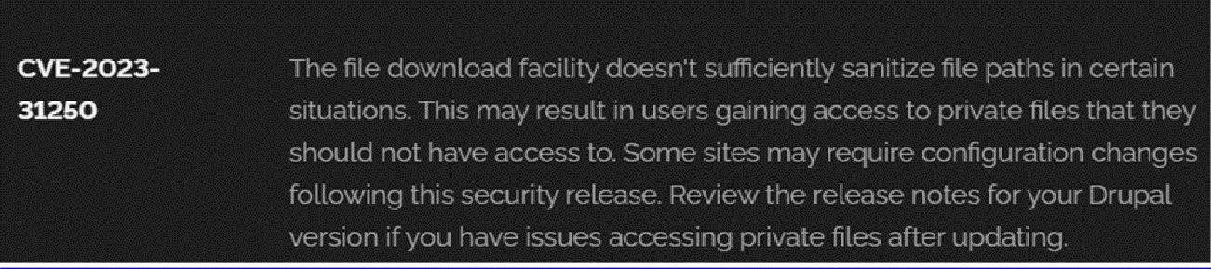

Recommendation:

- Apply Security Updates: The primary recommendation is to apply the security update providedbyDrupalassoonasitbecomesavailable.Securityupdatestypicallyincludefixesfor known vulnerabilities like this one.
- ReviewConfiguration:Afterapplyingtheupdate,reviewyourDrupalsite'sconfigurationto ensure that private files remain protected as intended. Make any necessary adjustments to your site's file permissions or access controls.
- RegularAudits:Conductregularsecurityauditsandvulnerabilityassessmentstoidentifyand address potential security issues in your Drupal site.
- AccessControl:Implementstrongaccesscontrolstoensurethatonlyauthorizeduserscan access private files. Review and restrict file access permissions as needed.
- DataMinimization:MinimizetheamountofsensitivedatastoredonyourDrupalsite.Only store data that is necessary for your site's functionality.

VulnerabilityName:InvalidCertificate

CWE-395:ImproperCertificateValidation

OWASPCategory:A07:2021–IdentificationandAuthenticationFailures

Description: When a certificate is invalid or malicious, it might allow an attacker to spoof a trustedentitybyinterferinginthecommunicationpathbetweenthehostandclient.Theproduct might connect to a malicious host while believing it is a trusted host, or the product might be deceived into accepting spoofed data that appears to originate from a trusted host.
Business Impact: Improper certificate validation can lead to a range of security threats which includesMan-in-the-middleattacks(Attackerscaninterceptcommunicationbetweentwoparties and read or modify the data exchanged between them),Data breaches:(Attackers can gain unauthorized access to sensitive information or sensitive systems, leading to data breaches),Malwaredistribution(Attackerscanusefakedigitalcertificatestodistributemalicious software or infect systems with malware)
StepstoReproduce:https://www.ssllabs.com/ssltest/analyze?d=www.itsecgames.com
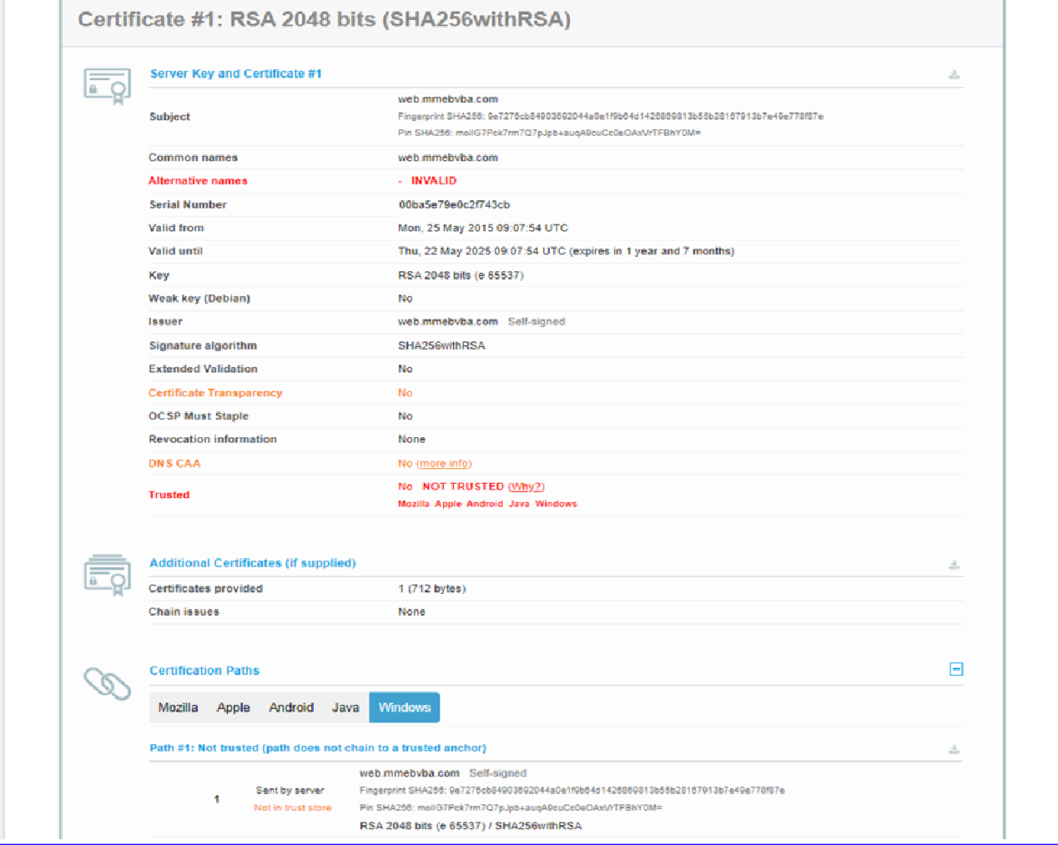

Recommendation:

- Usetrustedcertificateauthorities:Onlytrustdigitalcertificatesissuedbywell-knownand trusted certificate authorities.
- Verify certificate chains: Verifythat the certificatepresentedby the remotepartyis valid and issuedbyatrustedcertificateauthority.Verifythe entirecertificatechain,includingintermediate certificates.
- Checkcertificaterevocationstatus:Checktherevocationstatusofthecertificatepresented by the remote party to ensure that it has not been revoked.
- Usecertificatepinning: Implementcertificatepinningtoensurethatthecommunicationonly occurs with the exact certificate or certificate authority specified.
- Keepsoftwareuptodate:Keepsoftwareandsecurityprotocolsuptodate,asnew vulnerabilities and security patches are regularly released.

VulnerabilityName:MissingX-Frame-OptionsHeader

CWE-1021:DesignImproperRestrictionofRenderedUILayersor Frames

OWASPCategory:A04:2021-InsecureDesign

Description:Awebapplicationisexpectedtoplacerestrictionsonwhetheritisallowedtobe rendered within frames, iframes, objects, embed or applet elements. Without the restrictions, users can be tricked into interacting with the application when they were not intending to.
BusinessImpact:Thisenablespathtotheattackerstomanipulateorgainunauthorizedaccessto user interface elements, potentially leading to deceptive or malicious user interactions. This can result in data leakage, fraud, user distrust, and reputational damage, undermining the integrity and trustworthiness of the application and causing financial losses.
VulnerabilityPath:http://www.itsecgames.com/

StepstoReproduce:

- Openthepracticewebsitetoinspect

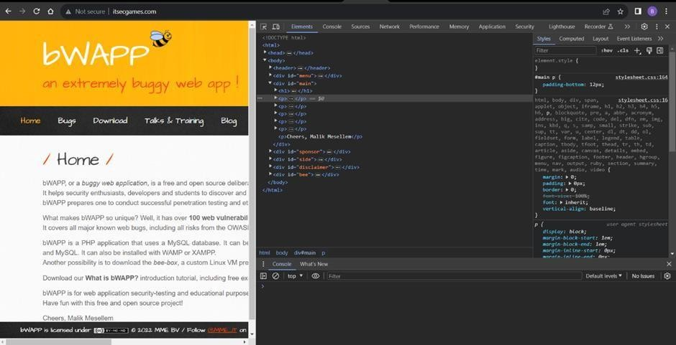

- Gotonetworkandstart capturingusingF5orCtrl+R

- Gotohtmldocumentandseeifx-frame-optionspresentinresponseheadersor not

- If not the absence of this header indicates that the website may not have protection against embeddingitscontentwithinaniframeonotherdomains,potentiallyleavingitvulnerableto clickjacking attacks.
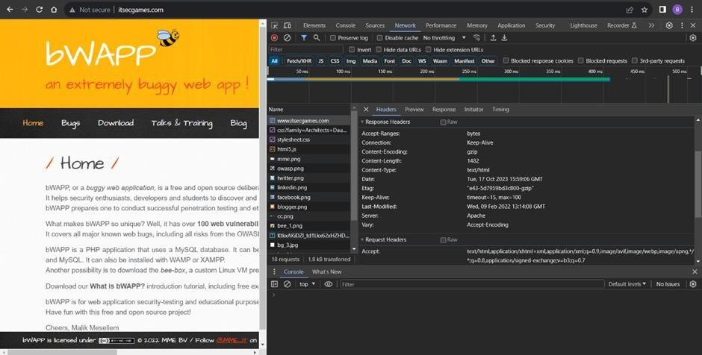

Recommendation:

- ImplementProperUILayerAccessControls:Enforceaccesscontrolstorestrictaccessto UI layers or frames based on user privileges.
- UseSessionandAuthenticationManagement:Ensurerobustsessionmanagementanduser authentication mechanisms to prevent unauthorized access.
- ImplementContentSecurityPolicies(CSP):UseCSPheaderstocontrolwhereresources can be loaded from and mitigate against frame-based attacks.
- KeepSoftwareandLibrariesUpdated:Staycurrentwithsoftwareupdatesandpatchesto address known security issues.

  - VulnerabilityName:X-Content-TypeOptionsHeaderMissing CWE -918: Server-Side Request Forgery (SSRF)
OWASPCategory:A10:2021–Server-SideRequestForgery (SSRF)

Description: The web server receives a URL or similar request from an upstream component andretrievesthecontentsofthisURL,butitdoesnotsufficientlyensurethattherequestisbeing sent to the expected destination.

BusinessImpact:TheheadermissingimpactDataExposure(Attackersmightforcetheserverto render sensitive data as HTML, leading to data exposure),Security Risks(Content type manipulation can increase security risks, potentially leading to breaches, data leaks, and unauthorized access), Brand and Reputation Damage(Successful attacks that exploit SSRF vulnerabilities can harm the organization's reputation and trustworthiness)
Vulnerability Path : https://securityheaders.com/?q=http%3A%2F%2Fwww.itsecgames.com%2F&followRedirects=on

StepstoReproduce:

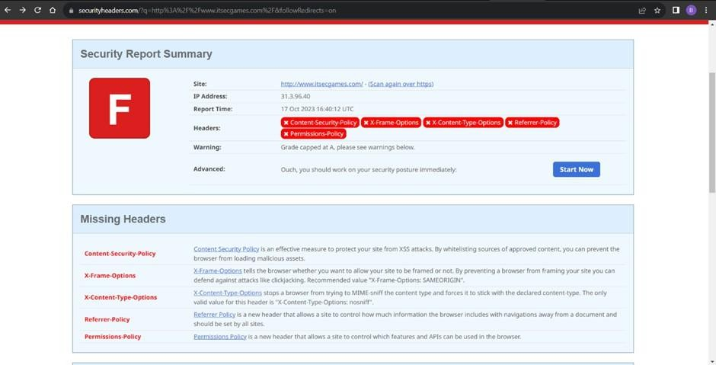
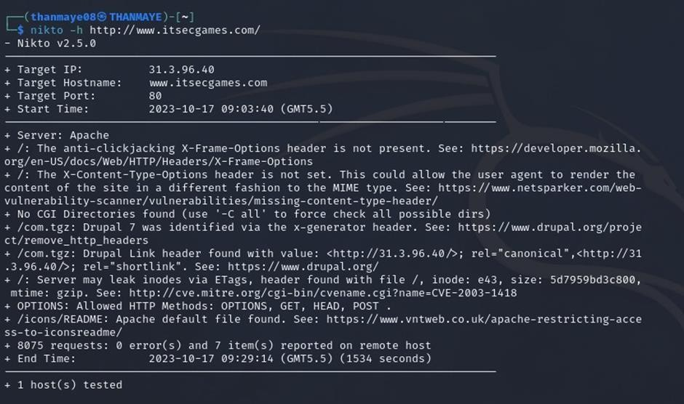
Recommendation:

- Implement"X-Content-Type-Options"Header:Configurethe"X-Content-Type-Options" header with the value "nosniff" in your web server or application to prevent content type sniffing.

- SecureSSRF:TodirectlymitigateSSRFvulnerabilities,ensureproperinputvalidation, access controls, and allow-list-based URL validation to prevent attackers from making unauthorized requests to internal resources.
- Security Headers: Implement other security headers like "X-Frame-Options" and "Content-Security-Policy"tofurtherenhancesecurityandmitigatevarioustypesofweb-based attacks.
Whilethe"X-Content-Type-Options"headermaynotbeadirectcountermeasuretoSSRF,itisa valuable security control that, when configured correctly, can help protect against content type- based attacks that may be exploited in SSRF scenarios.

VulnerabilityName:DrupalAjaxAPIshowsJSONPnotdisabledbydefault

CWE-937,1035:OWASPTopTen2013,2017CategoryA9-UsingComponentswithKnown Vulnerabilities
OWASPCategory:A06:2021-VulnerableandOutdatedComponents

Description:Vulnerableandoutdatedcomponentsrefertousingsoftwarelibraries,modules,or dependencieswithinawebapplicationthathaveknownsecurityissuesorarenotupdatedtothe latest secure versions. This can include plugins, frameworks, or APIs that are no longer maintained or have publicly documented vulnerabilities.
Business Impact: The presence of vulnerable and outdated components in a web application poses significant security risks. Attackers can exploit these weaknesses to gain unauthorized access,injectmaliciouscode,stealsensitivedata,ordisruptthesystem'soperation.Thepotential business impacts include compromised user data, damaged reputation, legal consequences, and financial losses due to breach recovery and remediation efforts.
VulnerabilityPath:https://www.shodan.io/host/31.3.96.40

StepstoReproduce:
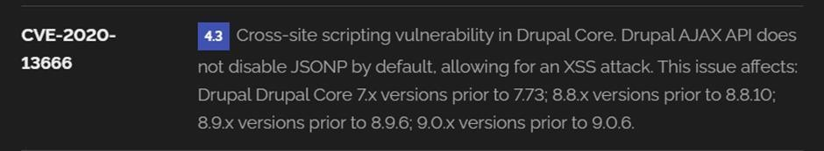

Recommendation:

- RegularUpdates:Keepallcomponents,libraries,anddependenciesuptodatebyapplying security patches and upgrades.
- VulnerabilityScanning:Conductperiodicvulnerabilityassessmentstoidentifyandaddress potential issues.
- DependencyManagement:Implementastrategyformanagingthird-partydependencies, including continuous monitoring of their security status.
- SecurityTesting:Performregularsecuritytesting,includingpenetrationtestingandcode review, to identify and remediate vulnerabilities.
- ChangeControl:Maintainachangemanagementprocesstoassesstheimpactofnew components and ensure they don't introduce new vulnerabilities.

  - VulnerabilityName:DrupalApiVulnerability CWE-20: Improper Input Validation
OWASPCategory:A03:2021–Injection

Description:Theproductreceivesinputordata,butitdoesnotvalidateorincorrectlyvalidates that the input has the properties that are required to process the data safely and correctly.
Business Impact: The impact of a successful SQL injection attack can be devastating for businesses. It can result in unauthorized access to sensitive information, data theft, financial losses,damagetoreputation,andlegalconsequences.Dependingonthenatureoftheapplication and data involved, SQL injection can lead to compliance violations, customer trust erosion, and operational disruption.
VulnerabilityPath:https://www.shodan.io/host/31.3.96.40

StepstoReproduce:
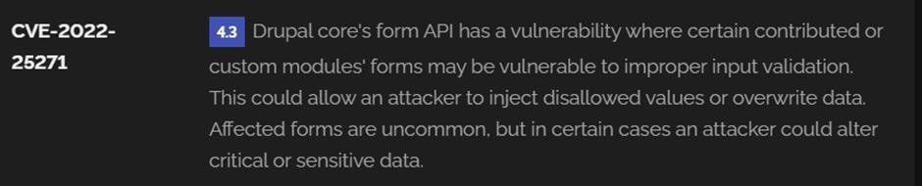

Recommendation:

- InputValidation:Implementrigorousinputvalidationonalluserinputsandensurethatonly safe, sanitized data is passed to the database.
- ParameterizedQueries:UseparameterizedqueriesorpreparedstatementstoseparateSQL code from user input, preventing malicious injections.
- EscapingUserInput:Ifparameterizedqueriesarenotfeasible,escapeuserinputbefore incorporating it into SQL queries to neutralize special characters.
- LeastPrivilegePrinciple:Limitthepermissionsandaccessrightsofdatabaseaccountstothe minimum required for specific tasks to minimize the potential damage of an attack.
- WebApplicationFirewalls(WAF):EmployWAFstofilterandblockmaliciousSQL injection attempts.
- RegularSecurityTesting:Conductregularsecurityassessments,includingpenetration testing, to identify and address vulnerabilities.

VulnerabilityName:ImproperAPI Filtration

CWE-79:ImproperNeutralizationofInputDuringWebPageGeneration('Cross-siteScripting')

OWASPCategory:A07-2017:Cross-siteScripting (XSS)

Description:Theproductdoesnotneutralizeorincorrectlyneutralizesuser-controllableinput before it is placed in output that is used as a web page that is served to other users.
Business Impact: If exploited, this vulnerability allows attackers to inject malicious scripts into web pages, which can be viewed by other users. The potential business impacts include data theft,unauthorizedaccess,compromiseduseraccounts,damagedreputation,andfinanciallosses. Attackers can use XSS to steal sensitive information, such as user credentials, personal data, or financial details, leading to regulatory compliance violations and legal liabilities. Additionally, defacement or manipulation of website content can erode customer trust and result in lost revenue.
VulnerabilityPath:https://www.shodan.io/host/31.3.96.40

StepstoReproduce:

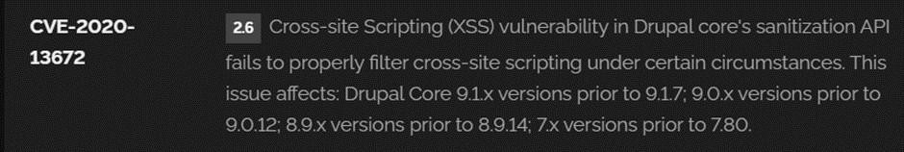

Recommendation:

- UpdateandPatch:EnsurethatDrupalandallrelatedmodulesandcomponentsareuptodate with the latest security patches to mitigate known vulnerabilities.
- InputValidation:Implementstronginputvalidationandoutputencodingtosanitizeuser inputs and prevent the injection of malicious scripts.
- ContentSecurityPolicy(CSP):ImplementCSPheaderstorestrictthesourcesfromwhich content can be loaded, reducing the risk of XSS.
- SecureCodingPractices:Traindevelopersinsecurecodingpractices,emphasizingthe importance of validating and escaping user inputs.
- SecurityScanning:Conductregularsecurityscansandpenetrationteststoidentifyand address XSS vulnerabilities.

VulnerabilityName:Denial ofService

CWE-400:Uncontrolled ResourceConsumption

OWASPCategory:

Description: The Denial of Service (DoS) attack is focused on making a resource (site, application, server)unavailable for thepurposeit wasdesigned. There are many waysto makea serviceunavailableforlegitimateusersbymanipulatingnetworkpackets,programming,logical, or resources handling vulnerabilities, among others. If a service receives a very large number of requests,itmayceasetobeavailabletolegitimateusers.Inthesameway,aservicemaystopifa programming vulnerability is exploited, or the way the service handles resources it uses.
Sometimes the attacker can inject and execute arbitrary code while performing a DoS attack in ordertoaccesscriticalinformationorexecutecommandsontheserver.Denial-of-serviceattacks significantlydegradetheservicequalityexperiencedbylegitimateusers.Theseattacksintroduce large response delays, excessive losses, and service interruptions, resulting in direct impact on availability.

Business Impact: If successfully exploited, it involves overwhelming a system or application with excessive demands on its resources. This can lead to a range of disruptive consequences. Thetargetedsystemmayexperiencesignificantslowdowns,orevencompleteunresponsiveness, making it difficult or impossible for legitimate users to access. Critical resources like CPU, memory, and network bandwidth can become depleted, causing further degradation in performance. In severecases, the exploited vulnerability may lead to system crashes or failures, potentially resulting in data loss. This disruption not only impacts business productivity and financial stability but also risks reputational damage, eroding customer trust and confidence.
Additionally, organizations may face regulatory compliance issues if the uncontrolled resource consumptionleadstoviolationsofservicelevelagreementsorindustrystandards.Mitigatingthis vulnerability requires proactive resource management practices and a well-prepared incident response plan to minimize the potential impacts on business operations and customer satisfaction.
StepstoReproduce:exploitopenports80toperformSQLinjections,cross-siterequest forgeries and DDoS attacks.
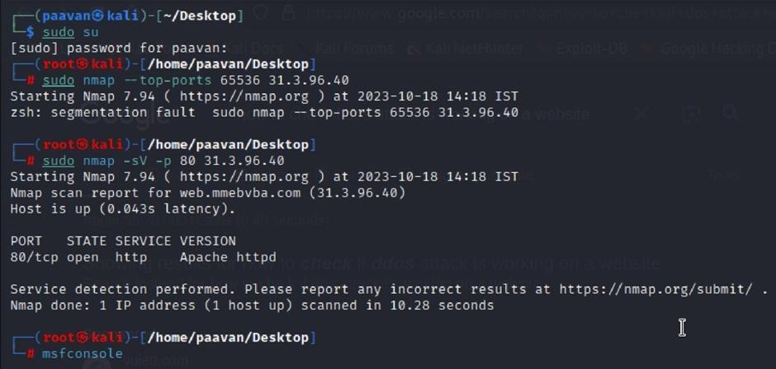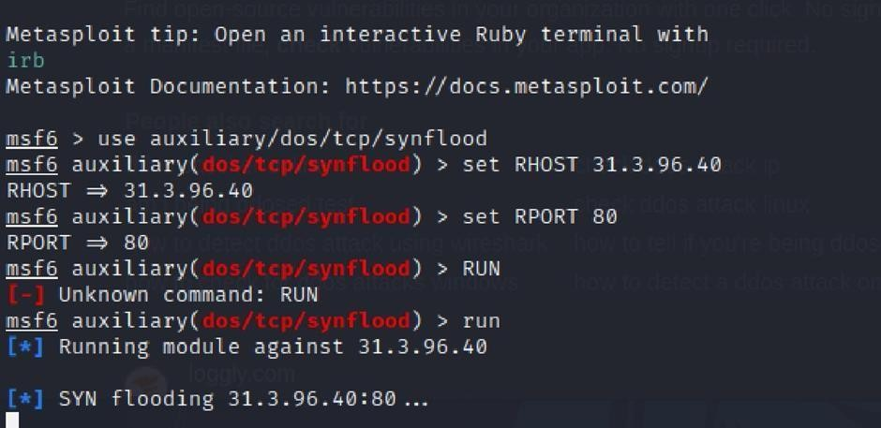

Recommendation: Employ a robust Web Application Firewall (WAF) capable offiltering and mitigating suspicious traffic targeting port 80. Configure it to block excessive requests or patterns indicative of an attack. Utilise load balancing techniques to distribute traffic across multipleservers,ensuringnosingleserverbecomesoverwhelmed.Additionally,implementrate limiting and throttling mechanisms to restrict the number of requests a single IP address can make within a defined time frame. Regularly monitor traffic patterns and set up alerts to detect unusual spikes in activity, enabling rapid response to potential attacks. Finally, keep software and systems up-to-date with the latest security patches to address known vulnerabilities that attackers may exploit.

  - Vulnerability Name: TLS Version 1.0 Protocol Detection CWE-327:UseofaBrokenorRiskyCryptographicAlgorithm OWASP Category: A02:2021-Cryptographic Failures
Description:Theproduct usesabrokenorriskycryptographicalgorithmor protocol.

Business Impact: TLS 1.0 is an outdated and vulnerable encryption protocol, and its use can expose sensitive data to potential security threats. This not only jeopardizes the integrity of customer information and payment details but also tarnishes the company's reputation. The businessmayfacelegalconsequences,lossofcustomertrust,anddecreasedrevenueassecurity- conscioususersavoidthesiteduetoitssecurityvulnerabilities.Immediateactionisnecessaryto upgrade to a more secure TLS version to safeguard data, ensure compliance, and maintain customer confidence.

StepstoReproduce:

- Openaterminalorcommand prompt

- TypetheCommand:openssl s_client-connect31.3.96.40:443 -tls1

- Theconnectionissuccessfullymeanstheserversupports TLS1.0

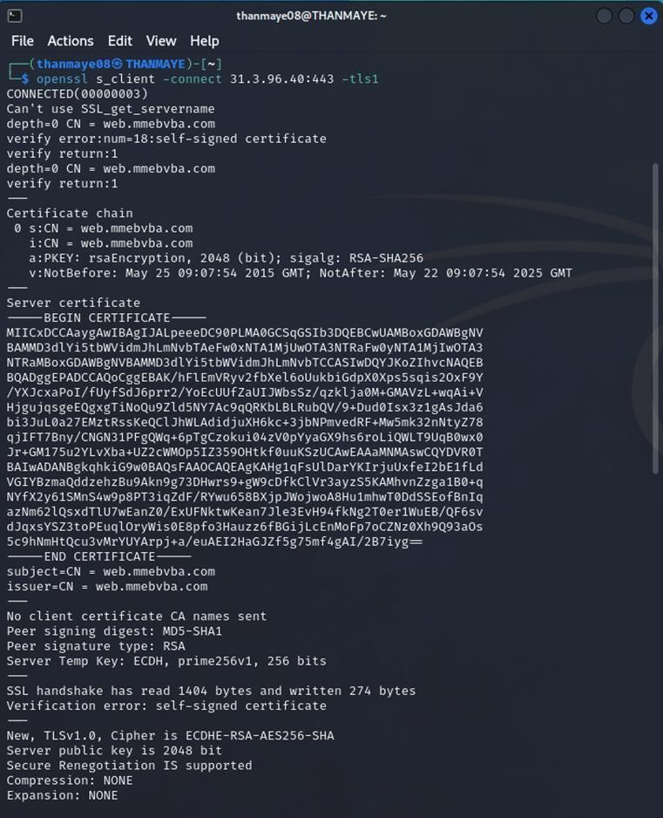

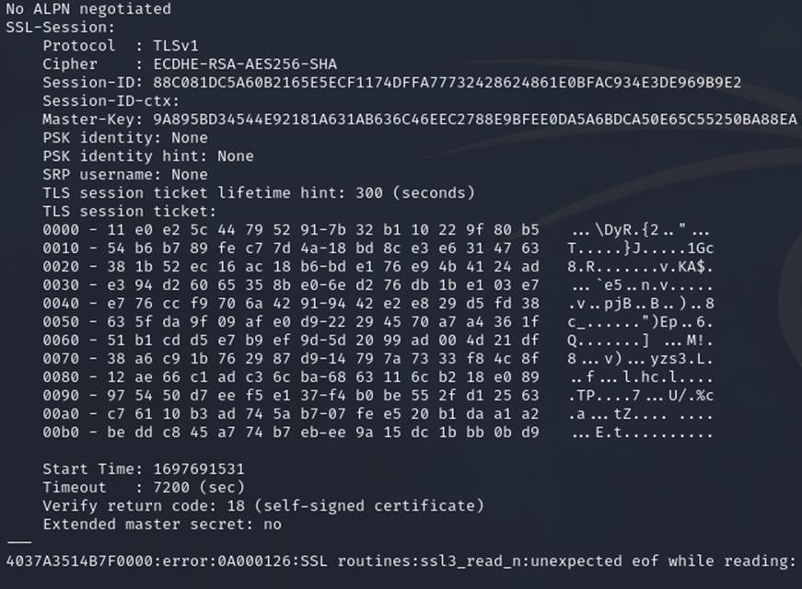

Recommendation:

- UpgradetoaSecureTLSVersion:TransitiontoamoresecureTLSversion,suchasTLS1.2 orTLS1.3.Thiswillprovidestrongerencryption andimprovedsecurityagainstmodernthreats.
- RegularlyUpdateSSL/TLSConfiguration:KeepyourSSL/TLSconfigurationuptodateto ensure it aligns with the latest security best practices and vulnerabilities.
- ImplementaStrongCryptographicSuite:Usestrongciphersuitesandsecureconfigurations to further enhance security. Disable weak ciphers and outdated protocols.
- ComplianceChecks:Ensurethatyourwebsitecomplieswithrelevantdataprotection regulations and industry standards (e.g., GDPR, PCI DSS) to avoid legal issues.

VulnerabilityName:web.configFileInformationDisclosure

CWE-497:Exposureof SensitiveSystemInformationtoanUnauthorizedControlSphere

OWASPCategory:A3:2017-SensitiveDataExposure

Description:Aninformationdisclosurevulnerabilityexistsintheremotewebserverduetothe disclosure of the web.config file. An unauthenticated, remote attacker can exploit this, via a simple GET request, to disclose potentially sensitive configuration information.
Business Impact: It exposes sensitive configuration details, including database connection stringsandencryptionkeys,topotentialattackers.Thiscouldleadtounauthorizedaccess,data breaches,andsystemcompromise.Theimpactincludesfinanciallosses,damagetoreputation, and legal liabilities as the organization's security and customer trust are compromised.

StepstoReproduce:
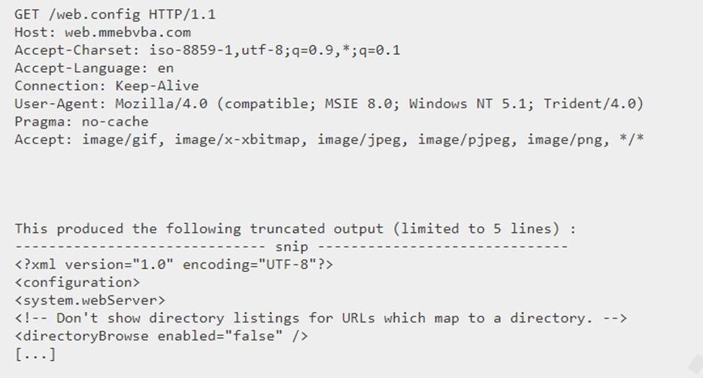

Recommendation:

- Implementproperaccess controlstorestrictaccesstotheweb.configfile.
- Preventdirectorytraversalandensuretheweb.configfilecannotbedirectlyaccessed through the web server.
- Encryptsensitivedatawithintheconfigurationfile.
- Regularlyreviewandupdatetheweb.configfile,removinganyunnecessarysensitive information.
- Ensurethattheweb.configfileisproperlysecuredandnotaccessibletounauthorized users.

MainWebsite:vtop.vit.ac.in

- VulnerabilityName:SLMediumStrengthCipherSuitesSupported(SWEET32) CWE-200: Exposure of Sensitive Information to an Unauthorised Actor
OWASPCategory:Brokenaccess control

Description: The remote host supports the use of SSL ciphers that offer medium strength encryption.Nessusregardsmediumstrengthasanyencryptionthatuseskeylengthsatleast64 bits and less than 112 bits, or else that uses the 3DES encryption suite.
Notethatitisconsiderablyeasiertocircumventmediumstrengthencryptioniftheattackerison the same physical network.
Business Impact: The vulnerability known as SWEET32 (Short for Sweet 32 Birthday Attack) relates to the continued use of legacy cryptographic cipher suites with 64-bit block sizes in TLS andSSLprotocols.Thesesuitesaresusceptibletobirthdayattacks,which exploitthe probability of two blocks colliding after a certain number of transactions. If an organisation's systems are vulnerabletoSWEET32,itmeansthey'repotentiallyatriskofhavingencryptedcommunications intercepted or manipulated. This could lead to unauthorised access, data theft, or even the injection of malicious code. As a result, businesses face a significant risk to the confidentiality and integrity of their sensitive information. Remediation involves updating systems to support more secure cipher suites with larger block sizes, which would effectively mitigate this vulnerability and enhance the overall security posture. Failure to address SWEET32 could leave an organisation exposed to increasingly sophisticated attacks and legal consequences due to potential data breaches.
VulnerabilityPath:TheSweet32vulnerabilitywhendetectedwithavulnerabilityscannerwill report it as a CVSS 7.5.

StepstoReproduce:

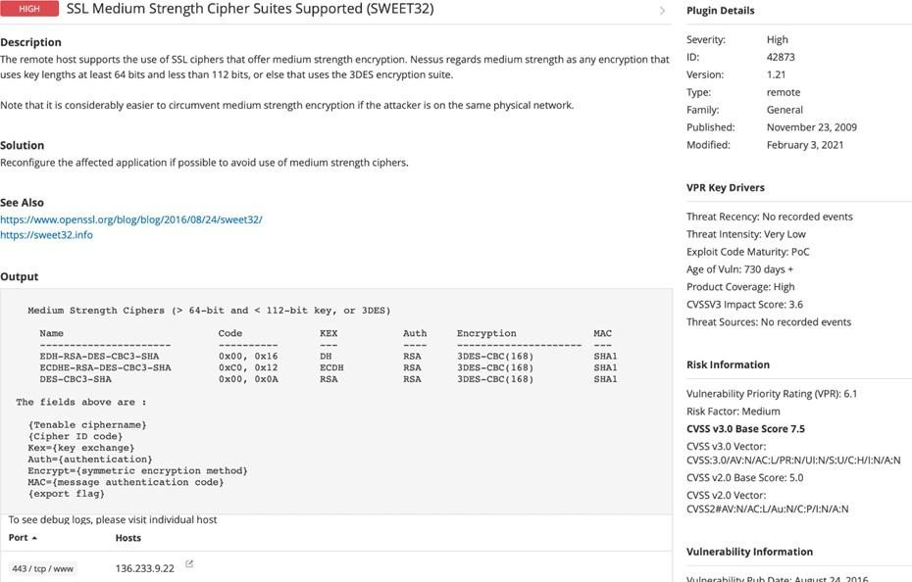
Recommendation: organisations should take several proactive steps. Firstly, it is crucial to update and configure cryptographic libraries, web servers, and any network devices to disable support for cipher suites with 64-bit block sizes. This can be achieved by ensuring that only modern and secure cipher suites are enabled in the TLS/SSL configurations. Additionally, organizations should regularly monitor and assess their systems for any outdated or vulnerable protocols and promptly apply security patches and updates. Implementing strong, unique encryption keys and employing forward secrecy protocols can further bolster security. It's also recommended to utilize intrusion detection systems and perform regular security audits to identify and address any potential vulnerabilities promptly. Lastly, organizations should stay informed about emerging security threats and best practices in cryptographic protocols to proactivelyadapttheirsecuritymeasures.Bytakingthesemeasures,businessescansignificantly reduce the risk of falling victim to SWEET32 attacks and enhance the overall security of their digital infrastructure.

- VulnerabilityName:CookieSERVERIDcreatedwithoutsecueflag CWE-79:ImproperNeutralizationofInputDuringWebPageGeneration OWASP Category: A07-2017: Cross-site Scripting

Description:ThevulnerabilityallowsanattackertoinjectmaliciouscodeintoaWordPress website, which can then be executed by visitors to the website.
To exploit this vulnerability, an attacker would simply need to trick a user into clicking on a maliciouslinkoropeningamaliciousattachment.Oncetheuserclicksonthelinkoropensthe attachment, the attacker's code would be executed, giving the attacker control over the user's account and potentially the entire WordPress website.
BusinessImpact:ThebusinessconsequencesofXSScanbesevere,rangingfromreputational damage due to compromised customer trust, to legal repercussions in cases of data breaches.
Moreover,itcanleadtofinanciallossesthroughfraudorthecostofremediationefforts.Beyond the immediate impacts, long-term harm may occur if customers abandon the platform due to security concerns. To mitigate CWE-79, businesses must implement rigorous input validation and output encoding practices, as well as stay vigilant for emerging threats in web application security. Failure to address XSS vulnerabilities could result in significant harm to both the business's reputation and its bottom line.
VulnerabilityPath:https://securityheaders.com/

q=http%3A%2F%2Fvtop.vit.ac.in%2F&followRedirects=on

StepstoReproduce:
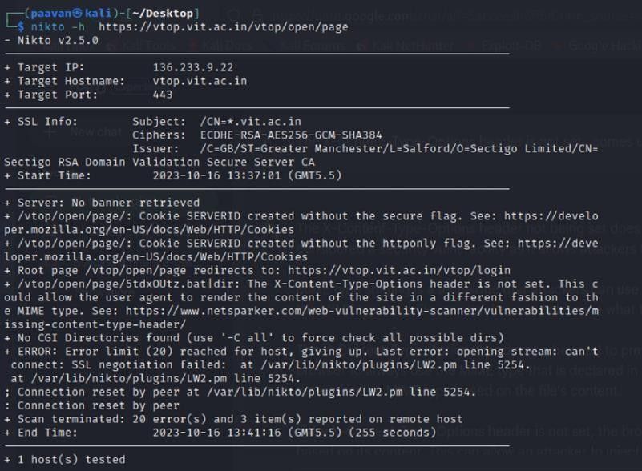

Recommendation:

- UpdateandPatch:EnsurethatDrupalandallrelatedmodulesandcomponentsareupto date with the latest security patches to mitigate known vulnerabilities.
- InputValidation:Implementstronginputvalidationandoutputencodingtosanitize user inputs and prevent the injection of malicious scripts.
- ContentSecurityPolicy(CSP):ImplementCSPheaderstorestrictthesourcesfrom which content can be loaded, reducing the risk of XSS.
- SecureCodingPractices:Traindevelopersinsecurecodingpractices,emphasizingthe importance of validating and escaping user inputs.
- SecurityScanning:Conductregularsecurityscansandpenetrationteststoidentifyand address XSS vulnerabilities.

- VulnerabilityName:X-Content-TypeOptionsHeaderMissing CWE-918: Server-Side Request Forgery (SSRF)
OWASPCategory:A10:2021–Server-SideRequestForgery(SSRF)

Description:Theabsenceofthe"X-Content-Type-Options"headerposesanotablesecurityrisk for web applications. This header is a crucial security feature that instructs the browser to interpret files with a MIME type as declared in the Content-Type header, rather than trying to guess the type. When this header is missing, the browser may attempt to infer the content type, leaving room for potential misinterpretation and security vulnerabilities like MIME-sniffing attacks. This could enable attackers to disguise malicious content, such as scripts or executable files, as benign content, leading to Cross-Site Scripting (XSS) or other types of attacks.
Implementingthe"X-Content-Type-Options"headerwiththevalue"nosniff"isafundamental security measure that helps prevent these risks. It ensures that browsers strictly adhere to the declared content type, enhancing the overall security posture of the web application and safeguarding against potential exploitation stemming from content misinterpretation.
BusinessImpact:TheheadermissingimpactDataExposure(Attackersmightforcetheserverto render sensitive data as HTML, leading to data exposure),Security Risks(Content type manipulation can increase security risks, potentially leading to breaches, data leaks, and unauthorized access), Brand and Reputation Damage(Successful attacks that exploit SSRF vulnerabilities can harm the organization's reputation and trustworthiness)

VulnerabilityPath:
https://securityheaders.com/?q=http%3A%2F%2Fvtop.vit.ac.in%2F&followRedirects=on

StepstoReproduce:

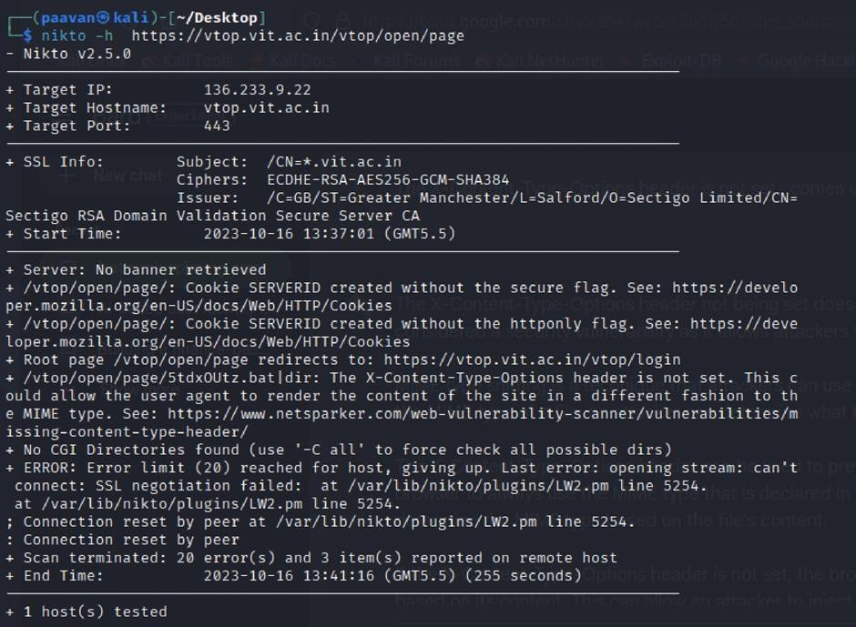

Recommendation:

- Implement"X-Content-Type-Options"Header:Configurethe"X-Content-Type-Options" header with the value "nosniff" in your web server or application to prevent content type sniffing.
- SecureSSRF:TodirectlymitigateSSRFvulnerabilities,ensureproperinputvalidation, access controls, and allow-list-based URL validation to prevent attackers from making unauthorized requests to internal resources.
- Security Headers: Implement other security headers like "X-Frame-Options" and "Content-Security-Policy"tofurtherenhancesecurityandmitigatevarioustypesofweb-based attacks.
Whilethe"X-Content-Type-Options"headermaynotbeadirectcountermeasuretoSSRF,itisa valuable security control that, when configured correctly, can help protect against content type- based attacks that may be exploited in SSRF scenarios.

VulnerabilityName:Denial ofService

CWE-400:UncontrolledResourceConsumption

Description: The Denial of Service (DoS) attack is focused on making a resource (site, application, server)unavailable for thepurposeit wasdesigned. There are many waysto makea serviceunavailableforlegitimateusersbymanipulatingnetworkpackets,programming,logical, or resources handling vulnerabilities, among others. If a service receives a very large number of requests,itmayceasetobeavailabletolegitimateusers.Inthesameway,aservicemaystopifa programming vulnerability is exploited, or the way the service handles resources it uses.
Sometimes the attacker can inject and execute arbitrary code while performing a DoS attack in ordertoaccesscriticalinformationorexecutecommandsontheserver.Denial-of-serviceattacks significantlydegradetheservicequalityexperiencedbylegitimateusers.Theseattacksintroduce large response delays, excessive losses, and service interruptions, resulting in direct impact on availability.
Business Impact: If successfully exploited, it involves overwhelming a system or application with excessive demands on its resources. This can lead to a range of disruptive consequences. Thetargetedsystemmayexperiencesignificantslowdowns,orevencompleteunresponsiveness, making it difficult or impossible for legitimate users to access. Critical resources like CPU, memory, and network bandwidth can become depleted, causing further degradation in performance. In severecases, the exploited vulnerability may lead to system crashes or failures, potentially resulting in data loss. This disruption not only impacts business productivity and financial stability but also risks reputational damage, eroding customer trust and confidence.
Additionally, organizations may face regulatory compliance issues if the uncontrolled resource consumptionleadstoviolationsofservicelevelagreementsorindustrystandards.Mitigatingthis vulnerability requires proactive resource management practices and a well-prepared incident response plan to minimize the potential impacts on business operations and customer satisfaction.
StepstoReproduce:exploitopenports443toperformSQLinjections,cross-siterequest forgeries and DDoS attacks.

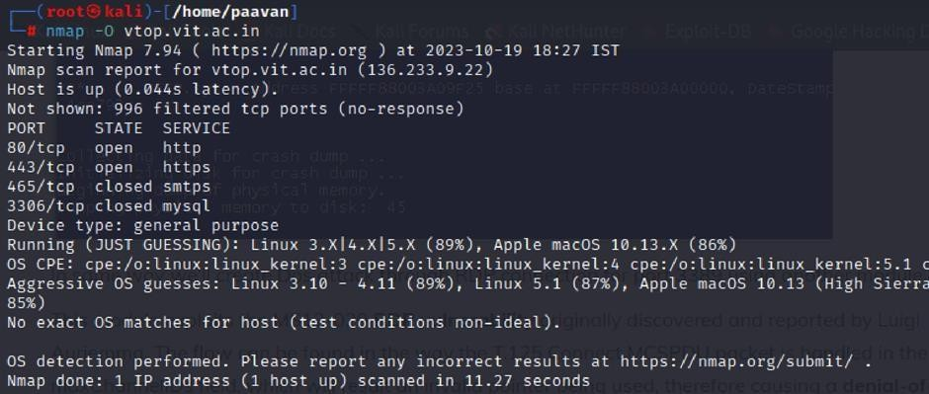
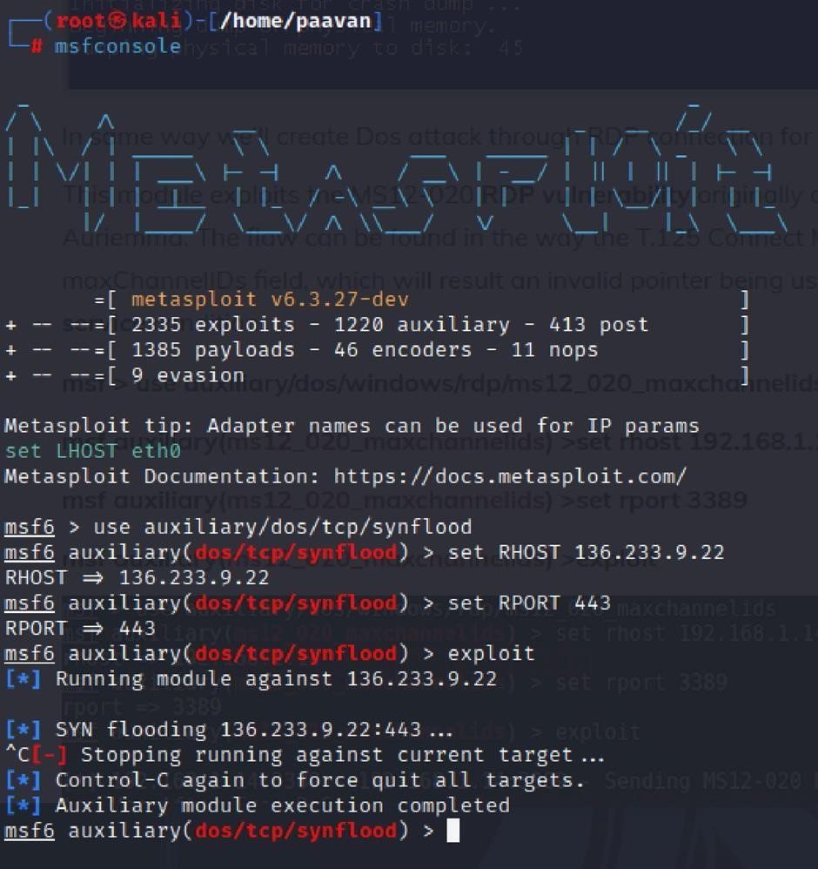

Recommendation: employ a robust Web Application Firewall (WAF) capable of filtering and mitigating suspicious traffic targeting port 80. Configure it to block excessive requests or patterns indicative of an attack. Utilise load balancing techniques to distribute traffic across multipleservers,ensuringnosingleserverbecomesoverwhelmed.Additionally,implementrate limiting and throttling mechanisms to restrict the number of requests a single IP address can make within a defined time frame. Regularly monitor traffic patterns and set up alerts to detect unusual spikes in activity, enabling rapid response to potential attacks. Finally, keep software and systems up-to-date with the latest security patches to address known vulnerabilities that attackers may exploit.

VulnerabilityName:OSIdentification

CWE-200:ExposureofSensitiveInformationtoanUnauthorised Actor

OWASPCategory:A02:2021-CryptographicFailures

Description:Usingacombinationofremoteprobes(e.g.,TCP/IP,SMB,HTTP,NTP,SNMP, etc.), it is possible to guess the name of the remote operating system in use. It is also possible sometimes to guess the version of the operating system.
Business Impact: If sensitive information is improperly handled or inadequately protected, it can lead to financial losses, regulatory penalties, and damage to reputation. Customers may lose trustintheorganization'sabilitytosafeguardtheirdata,potentiallyresultinginalossofbusiness and market share. Legal consequences and compliance issues may arise, leading to additional costs. Moreover, intellectual property theft or exposure can compromise a company's competitive edge. Remediation efforts, including implementing stronger security measures and compensatingaffectedparties,canalsoentailsubstantialexpenses.Overall,CWE-200highlights thecriticalimportanceofrobustdataprotectionmeasurestosafeguardanorganization'sfinancial health, reputation, and long-term viability.
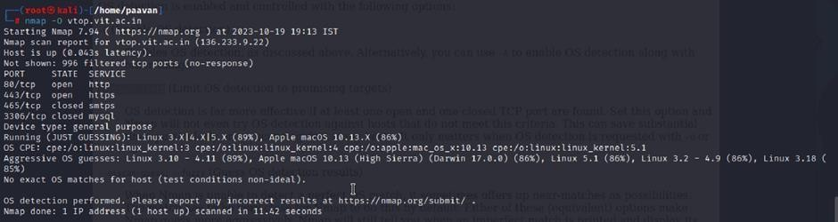
StepstoReproduce:usenmap-OTARGETtoenableosdetection

Recommendation:implementingrobustencryptionprotocolsfordatabothintransitandatrest, coupledwithstringentaccesscontrolsandstrongauthenticationmeasures. Regularvulnerability assessments and penetration testing should be conducted to identify and rectify potential weak points. Educating employees through comprehensive security awareness training is vital, emphasising proper data handling practices and recognition of potential threats. Employing data masking techniques for non-production environments and utilising advanced Data Loss Prevention (DLP) solutions can further fortify defences. Additionally, maintaining compliance withrelevantdataprotectionlawsandregulations,aswellasestablishingawell-definedincident responseplan,arecrucialcomponentsofacomprehensivestrategytosafeguardagainstsensitive information exposure.

Thisisstage1inthecontextofwebapplicationtestingandsecurity we take help from
OWASPtop10tounderstandthem.TheOWASPTop10isawidelyrecognizedlistofthemost critical web application security risks. Understanding these risks is essential for ensuring the security of web applications.

Stage2

Overview:-

NessusisavulnerabilityscannerdevelopedbyTenable,Inc.Itisaremotescanner,meaningthat itdoesnotneedtobeinstalledonthetargethostto scanit.Nessusworksby sendingavarietyof probes to the target host in order to identify vulnerabilities. These probes can include network traffic, operating system commands, and application requests.

Nessususesaplugin-basedarchitecture.Pluginsaresmallpiecesofcodethataredesignedto identifyspecificvulnerabilities.Thereareover1200pluginsavailableforNessus,coveringa wide range of vulnerabilities in operating systems, applications, and network devices.

When Nessus scans a host, it first uses a discovery plugin to identify the operating system and servicesrunningonthehost.Oncethehosthasbeendiscovered,Nessusrunsaseriesofplugins to test for vulnerabilities. For each vulnerability that Nessus finds, it provides a detailed report that includes the severity of the vulnerability, the steps to reproduce the vulnerability, and the steps to remediate the vulnerability.

Nessus can be used to scan a variety of targets, including single hosts, networks, and web applications.Itcanalsobeusedtoscanspecificportsandservices.Nessuscanbeconfiguredto run scans on a schedule or manually.

Hereisastep-by-step explanationofhowNessusworks:

- Nessusconnectstothetargethostusingavarietyofprotocols,includingTCP,UDP,and ICMP.
- Nessussendsaseriesofprobestothetargethostinordertoidentifyitsoperatingsystem and services.
- Nessusrunsaseriesofpluginstotestforvulnerabilities.
- Nessusgeneratesareportthatincludestheseverityofeachvulnerability,thestepsto reproduce the vulnerability, and the steps to remediate the vulnerability.

Nessus is a valuable tool for security professionals who need to identify and remediate vulnerabilitiesintheirnetworks.Itiseasytouseandprovidescomprehensivereportsthatcanbe used to prioritise remediation efforts.

Herearesomeof thebenefitsof usingNessus:

  - Comprehensivevulnerabilitycoverage:Nessushasover1200pluginsavailable,covering a wide range of vulnerabilities in operating systems, applications, and network devices.
  - Easytouse:Nessushasauser-friendlyinterfacethatmakesiteasytoconfigureandrun scans.
  - Comprehensivereporting:Nessusprovidesdetailedreportsthatincludetheseverityof each vulnerability,the steps to reproduce the vulnerability, and the steps to remediate the vulnerability.
  - Scalability:Nessuscanbeusedtoscanavarietyoftargets,includingsinglehosts, networks, and web applications.
  - Flexibility:Nessus canbeconfiguredtorunscansonascheduleor manually.

Nessusisapowerfultoolthatcanbeusedtoimprovethesecurityofanynetwork. Itisavaluable asset for any security professional.

Targetwebsite:-http://testfire.net/
Targetipaddress:-65.61.137.117

List ofvulnerability:-

s.no | Vulnerabilityname | Severity | plugins
1 | TLSVersion1.0 Protocol  Detection | MEDIUM | 104743
2 | TLSVersion1.1 Protocol  Deprecated | MEDIUM | 157288
3 | SSL/TLSDiffie-HellmanModulus  <=1024 Bits(Logjam) | LOW | 83875
4 | ICMPTimestampRequest Remote  DateDisclosure | INFO | 10114
5 | AdditionalDNSHostnames | INFO | 46180
6 | ApacheTomcatDetection | INFO | 39446
7 | CommonPlatformEnumeration  (CPE) | INFO | 45590
8 | DeviceType | INFO | 54615
9 | HSTSMissingFromHTTPSServer | INFO | 84502
10 | HTTPServerTypeandVersion | INFO | 10107

REPORT:-

- VulnerabilityName:-104743-TLSVersion1.0ProtocolDetection Severity: - MEDIUM
Plugin:-104743

Port:-443
Description:-TheremoteserviceacceptsconnectionsencryptedusingTLS1.0.TLS1.0hasa number of cryptographic design flaws. Modern implementations of TLS 1.0 mitigate these problems, but newer versions of TLS like 1.2 and 1.3 are designed against these flaws and should be used whenever possible.

AsofMarch31,2020,Endpointsthataren’tenabledforTLS1.2andhigherwillnolonger function properly with major web browsers and major vendors.
PCI DSS v3.2 requires that TLS 1.0 be disabled entirely by June 30, 2018, except for POS POI terminals(andtheSSL/TLSterminationpointstowhichtheyconnect)thatcanbeverifiedasnot being susceptible to any known exploits.
Solution:-EnablesupportforTLS1.2 and1.3,anddisablesupportforTLS 1.0.
BusinessImpact:-ContinueduseofTLS1.0'sencryption,knownforitsinherentcryptographic flaws, exposes the organization to heightened security risks, increasing the likelihood of data breaches and cyberattacks. This vulnerability jeopardizes compliance with industry standards, specifically PCI DSS v3.2, which mandates the complete cessation of TLS 1.0 use. Non- compliance risks regulatory penalties and erodes customer trust. Moreover, endpoints that lack supportforTLS1.2andhigherwillexperienceimpairedfunctionalitywithmajorwebbrowsers and vendors, potentially leading to lost business opportunities and damage to the organization's reputation. Addressing this vulnerability is imperative to mitigate these multifaceted risks and maintain a secure and trustworthy online presence.

VulnerabilityName:-157288-TLSVersion1.1ProtocolDeprecated Severity: - MEDIUM
Plugin:-157288

Port:-443
Description: - The remote service accepts connections encrypted using TLS 1.1. TLS 1.1 lacks supportforcurrentandrecommendedciphersuites.CiphersthatsupportencryptionbeforeMAC computation, and authenticated encryption modes such as GCM cannot be used with TLS 1.1As of March 31, 2020, Endpoints that are not enabled for TLS 1.2 and higher will no longer function properly with major web browsers and major vendors.
Solution:-EnablesupportforTLS1.2and/or1.3,anddisablesupportforTLS 1.1.

Business Impact: -The continued use of TLS 1.1 with its lack of support for modern cipher suites and advanced encryption methods jeopardizes the organization's security posture, increasingvulnerabilitytocyberthreatsandpotentialdatabreaches.Additionally,endpointsnot upgraded to support TLS 1.2 and higher will encounter compatibility issues with major web browsers and vendors, impacting user experience and potentially leading to missed business opportunities. Swift remediation of this vulnerability is essential to mitigate security risks and ensure seamless interactions with web browsers and vendors, preserving the organization's reputation and operational efficiency.

VulnerabilityName:-83875-SSL/TLSDiffie-HellmanModulus<=1024Bits(Logjam) Severity: - LOW
Plugin:-83875

Port:-443
Description:-TheremotehostallowsSSL/TLSconnectionswithoneormoreDiffie-Hellman moduli lessthan or equal to 1024 bits. Through cryptanalysis, athird party may beable to find thesharedsecretinashortamountoftime(dependingonmodulussizeandattackerresources). This may allow an attacker to recover the plaintext or potentially violate the integrity of connections.
Solution:-ReconfiguretheservicetouseauniqueDiffie-Hellmanmoduliof2048bitsor greater.
Business Impact: - Allowing SSL/TLS connections with weak Diffie-Hellman moduli raises securityconcerns.Anattackerwithsufficientresourcesandcomputingpowercouldcompromise the shared secret relatively quickly, potentially leading to the decryption of sensitive data or the violationofconnectionintegrity.Whiletheseverityislow,theriskofdatabreachesandintegrity compromise should not be underestimated, and it is essential to address this vulnerability to maintain data security and user trust.

VulnerabilityName:-10114-ICMPTimestampRequestRemoteDateDisclosure Severity: - INFO
Plugin:-10114

Port:-0
Description: - The remote host answers to an ICMP timestamp request. This allows an attacker toknowthedatethatissetonthetargetedmachine,whichmayassistanunauthenticated,remote attacker in defeating time-based authentication protocols.
TimestampsreturnedfrommachinesrunningWindowsVista/7/2008/2008R2are deliberately incorrect, but usually within 1000 seconds of the actual system time.
Solution:-FilterouttheICMPtimestamprequests(13),andtheoutgoingICMPtimestamp replies (14).
Business Impact: -This does not pose an immediate threat to business operations or data security. This vulnerability allows external parties to request the system's date and time informationremotely.Whileitdoesnotpresentasignificantrisk,itcouldpotentiallybeusedby attackers for reconnaissance purposes. Therefore, it is advisable to address this vulnerability as part of a broader security posture to reduce the risk of unauthorized data gathering and protect against potential future threats.

VulnerabilityName:-46180-AdditionalDNSHostnames Severity: - INFO
Plugin:-46180

Port:-0
Description: - Hostnames different from the current hostname have been collected by miscellaneousplugins.Nessushasgeneratedalistofhostnamesthatpointtotheremotehost. Note that these are only the alternate hostnames for hosts discovered on a web server.

Differentwebserversmaybehostedonname-basedvirtual hosts.
Solution:-Ifyouwanttotestthem,re-scanusingthespecialvhostsyntax,suchas: www.example.com [192.0.32.10]
Business Impact: -This does not pose an immediate threat to business operations or data security. It indicates the discovery of hostnames that are associated with the remote host, particularlyincasesofwebserversutilizingname-basedvirtualhosts.Whilenotasecurityrisk on its own, it could be useful for understanding the server's configuration and infrastructure.
Organizationsshouldconsiderthisinformationaspartoftheirnetworkdocumentationbutdonot need to take immediate action to mitigate it as a security threat.

VulnerabilityName:-39446-ApacheTomcatDetection Severity: - INFO
Plugin:-39446

Port:-80
Description:-NessuswasabletodetectaremoteApacheTomcatwebserver.

Solution:-n/a
Business Impact: -Is an informational finding that identifies the presence of a remote Apache Tomcatwebserver.Whilethisinformationitselfdoesnotindicateasecuritythreatorimpacton businessoperations, itcan beusefulfor network administratorsand securityprofessionalsto be aware of the technologies in use on their network. Understanding the presence of an Apache Tomcat server can be valuable for maintaining and securing web applications, but it does not require immediate action to mitigate a security risk.

VulnerabilityName:-45590-CommonPlatformEnumeration(CPE) Severity: - INFO
Plugin:-45590

Port:-0
Description: - By using information obtained from a Nessus scan, this plugin reports CPE (CommonPlatformEnumeration)matchesforvarioushardwareandsoftwareproductsfoundon a host.
NotethatifanofficialCPEisnotavailablefortheproduct,thisplugincomputesthebest possible CPE based on the information available from the scan.

Solution:-n/a
Business Impact: - This provides insights into hardware and software products identified on a hostthroughaNessusscan.ItreportsCPEmatches,whicharestandardizedidentifiersforthese products. This information is valuable for asset management and inventory purposes. While it doesn't signify a security threat, it aids administrators in understanding the components within their network, contributing to effective resource management and facilitating future system maintenance.

VulnerabilityName:-DeviceType Severity: - INFO
Plugin:-54615

Port:-0
Description:-Basedontheremoteoperatingsystem,itispossibletodeterminewhattheremote system type is (eg: a printer, router, general-purpose computer, etc).

Solution:-
BusinessImpact:-Itallowsfortheidentificationoftheremotesystemtype,suchasaprinter, router,orgeneral-purposecomputer,basedontheremoteoperatingsystem.Whilethisdoesn't pose a direct security threat, it offers valuable insights for network administrators to better understand and classify the devices in their network. This information aids in network

management,optimization,andensuresthattherightsecuritymeasuresareinplaceforeach device type.

VulnerabilityName:-84502-HSTSMissingFromHTTPSServer Severity: - INFO
Plugin:-84502

Port:- 443
Description: -The remote HTTPS server is not enforcing HTTP Strict Transport Security (HSTS).HSTSisanoptionalresponseheaderthatcanbeconfiguredontheservertoinstructthe browser to only communicate via HTTPS. The lack of HSTS allows downgrade attacks, SSL- stripping man-in-the-middle attacks, and weakens cookie-hijacking protections.
Solution:-ConfiguretheremotewebservertouseHSTS.
Business Impact: -Indicates that the remote HTTPS server does not enforce HTTP Strict Transport Security (HSTS). HSTS is a crucial security feature that, when configured on the server, instructs web browsers to communicate exclusively via HTTPS, enhancing security. The absenceofHSTSpotentiallyexposestheservertodowngradeattacks,SSL-strippingman-in-the- middle attacks, and weakens protections against cookie hijacking, posing risks to data confidentiality and user security. Enabling HSTS is essential to ensure a higher level of protection for data transmitted between clients and the server.

VulnerabilityName:-10107-HTTPServerTypeandVersion Severity: - INFO
Plugin:-10107

Port:-443

Description:-Thispluginattemptstodeterminethetypeandtheversionoftheremoteweb server.

Solution:-N/A
Business Impact: -This relates to the identification of the remote web server's type and version. Whilethisissuedoesn'tposeanimmediatesecuritythreat,itcanprovidevaluableinformationto potential attackers about the server's software stack. Knowledge of the server type and version may aid attackers in exploiting known vulnerabilities specific to that software, making it importanttorestrictsuchinformationfrombeingeasilyaccessibletoenhancetheserver'soverall security posture.

Stage-3

Title:-IntegrateZscalerwithIdentityProviders(IdPs)suchasAzureAD,Okta,and Active Directory for seamless authentication and authorization.

LegacyAuthenticationChallenges

BeforeimplementingZscaler-IdPintegration,organizationstypicallyfacesignificantchallengeswithlegacy authentication models. Traditional VPN architectures operate on an "authenticate once, trust indefinitely" principle, granting users network-level access upon successful authentication. This creates several critical issuesincludingover-permissionedaccesswhere userscandiscoverandattackothersystemsthroughlateral movement. VPN concentrators must be exposed to the public internet with open ports, making them visible targets for port scanning, brute-force attacks, and vulnerability exploitation. User experience suffers from traffichair-pinningwhereremotetrafficisroutedthroughthedatacenterbeforereachingtheinternet,causing latency. Hardware VPN appliances have hard capacity limits requiring manual upgrades during peak usage periods. IT staff must constantly patch, upgrade, and maintain physical VPN appliances. Most critically, legacy models lack integration with modern identity providers, forcing administrators to manage duplicate user accounts across multiple systems. These challenges create an urgent need for a modern identity-centric approach where authentication is delegated to enterprise IdPs and access is granted based on identity rather than network location.

ZeroTrustIdentity Principles

The integration of Zscaler with Identity Providers is fundamentally rooted in Zero Trust Architecture principlesthattransformhowauthenticationandauthorizationarehandled.Thecoreprincipleof"nevertrust, alwaysverify"meanseveryaccessrequestisfullyauthenticatedandauthorizedregardlessofwhethertheuser is in the office or working remotely. "Least privilege access" ensures users are granted only the minimum accessnecessarytoperformtheirjobfunctions,enforcedthroughidentity-basedpoliciesratherthannetwork location. "Assume breach" guides the design as if attackers are already present, requiring continuous verification of every session. "Micro-segmentation" isolates users and applications from one another to preventlateralmovement,achievedbyconnectinguserstospecificapplicationsratherthantheentirenetwork. Identity becomes the new perimeter, replacing the traditional castle-and-moat model where the internal network was considered trusted. Authentication must be explicit and contextual, incorporating user identity, device health, location, and behavior patterns. Authorization decisions are made dynamically based on real- time risk assessments rather than static rules. These principles directly inform how Zscaler integrates with IdPs to createasecurity model whereidentity is theprimarycontrol planeand access is grantedapplication- by-application rather than network-by-network.

SupportedIdentityProvidersandProtocols

Zscalersupportsintegrationwithacomprehensiverangeofidentityprovidersthroughstandardizedprotocols, ensuring flexibility for diverse enterprise environments. Microsoft Entra ID (Azure AD) integration utilizes SAML2.0forfederatedauthenticationandSCIMforautomateduserprovisioning,enablingorganizationsto leverage Azure AD's Conditional Access policies and extensive reporting capabilities. Okta integration leverages OpenID Connect (OIDC) for modern API-friendly authentication and SCIM for lifecycle management,withpre-builtconnectorsavailablethroughtheOktaIntegrationNetwork(OIN)forstreamlined setup. On-premises Active Directory integration is achieved through the Zscaler Authentication Bridge (ZAB), a lightweight connector that enables secure LDAP communication between Zscaler cloud services andinternaldomaincontrollerswithoutrequiringinboundfirewallrules.TheZABconnectorsitsbehindthe firewall and initiates outbound connections to Zscaler, proxying authentication requests and synchronizing group membership information. Additional supported IdPs include Ping Identity, OneLogin, and generic SAML 2.0 providers, ensuring organizations can maintain their existing identity investments. Protocol supportencompassesSAML2.0forbrowser-basedSSO,OIDCformobileandmodernapplicationscenarios, LDAP foron-premises directoryintegration, and SCIM 1.1/2.0 forautomated userprovisioning. This multi- protocol approach ensures comprehensive coverage across all access scenarios and user device types.

PrerequisitesandLicensing Requirements

Successful implementation of Zscaler-IdP integration requires specific prerequisites and licensing to be in place before beginning the project. Zscaler Internet Access (ZIA) and/or Zscaler Private Access (ZPA) subscriptionsmustbeactivewithappropriateusercountlicensingthatincludesSSOandSCIMprovisioning capabilities. Administrative access to the Zscaler Admin Portal with Super Admin or appropriate delegated admin roles is required to configure authentication settings and identity provider configurations. For cloud IdPintegration,administrativeaccesstoAzureADorOktawithpermissionstocreateenterpriseapplications, configureSAMLendpoints,andmanageAPIpermissionsforSCIMprovisioningisessential.Foron-premises Active Directory integration, a Windows Server environment is required to host the Zscaler Authentication Bridge (ZAB) with outbound internet access to connect to Zscaler cloud services. Network prerequisites includefirewall rules allowing outbound HTTPS(TCP 443)connections from ZAB serversto Zscalercloud endpoints,andfromuserdevicestoZscalerenforcementnodes.DNSresolutionmustbeproperlyconfigured for Zscaler cloud services and internal domain controllers. Certificate management requires valid SSL certificates for SAML assertion signing if custom certificates are preferred over Zscaler-generated options. User attribute planning must identify which directory attributes (email, UPN, group memberships) will be used for policy enforcement and application segmentation.

DiscoveryandRequirementsGathering
The discovery phase establishes the foundation for successful integration by documenting current identity infrastructure and access requirements. Begin by cataloging all internal applications currently accessed via legacy VPN, including student information systems, ERP platforms, library resources, research computing clusters, internal file servers, and administrative portals. For each application, document the protocol (HTTP/HTTPS,RDP,SSH,SMB),portnumbers,IPaddressesorhostnames,anduserpopulationsrequiring access. Conduct user segmentation workshops to define logical groups based on job functions and access needs,suchasfacultyrequiringaccesstoresearchservers,studentsneedinglibraryresources,staffaccessing administrativeportals,ITadministratorsmanagingserverinfrastructure,andexternalcollaboratorsrequiring limitedapplicationaccess.Documentexistingidentitysourcesincludingwhichdirectories(AzureAD,Okta, on-premisesAD)areauthoritativeforeachuserpopulation.Identifycurrentauthenticationmethodsincluding MFA requirements, password policies, and any existing SSO implementations.

IdentitySourceArchitecture Planning

Planning the identity source architecture requires careful consideration of which directories will serve as authoritative sources for different user populations. For organizations with hybrid identity infrastructure, determine whether Azure AD will be the primary authentication source with synchronization from on- premisesADviaAzureADConnect,orifdirecton-premisesADintegrationviaZABispreferredforspecific usecases.Documentthedirectorysynchronizationtopologyincludingwhichuserattributesaresynchronized, howgroupmembershipsaremanaged,andthefrequencyofdirectoryupdates.Planattributemappingbetween identity provider directory schemas and Zscaler user attributes, ensuring critical fields such as userPrincipalName, email, givenName, sn, and group memberships are properly mapped. For Azure AD integration, decide whether to use SAML-based authentication with optional SCIM provisioning, or OIDC for modern authentication scenarios. For Okta integration, plan the Okta Universal Directory schema and determine which profile attributes will be passed to Zscaler during authentication and provisioning. For on- premisesADintegrationviaZAB,documentdomaincontrollerlocations,networklatencybetweensites,and high availability requirements for the ZAB connector deployment. Consider disaster recovery scenarios including failover between identity providers and offline access capabilities. Plan for phased migration of user populations from legacy authentication to Zscaler-IdP integration, starting with pilot groups and expanding to full production.

ApplicationDiscoveryandCategorization

Comprehensiveapplicationdiscoveryensuresallresourcesrequiringprotectedaccessareproperlyidentified and categorized before policy configuration. Deploy network discovery tools or analyze firewall logs to identify all internal applications and services accessed by remote users over the past 90 days. For each discovered application, capture the fully qualified domain name (FQDN) or IP address, transport protocol (TCP/UDP), port number, and application type (web, RDP, SSH, SMB, database). Interview application owners and department heads to validate discovered applications and identify any shadow IT resources not captured in logs. Categorize applications by sensitivity level, such as public information, internal use only, confidential, and restricted, to inform policy stringency. Document application dependencies, such as applicationsthatrequireaccesstobackenddatabasesorauthenticationservices,toensurepropersegmentation without breaking functionality. Identify applications that share common infrastructure but require different access policies, such as multiple virtual hosts on the same web server. Create an application inventory spreadsheet with columns for application name, description, owner department, technical contact, protocol, port,destinationIP/FQDN,userpopulations,sensitivitylevel,andanyspecialaccessrequirements.Validate application discovery findings with IT operations teams to ensure no critical systems are missed. Prioritize applications for initial ZPA configuration based on business criticality and current VPN dependency.

UserGroupDefinitionandAttributePlanning

Defining user groups and planning directory attributes is essential for creating granular access policies in Zscaler.WorkwithHRanddepartmentleaderstoidentifyfunctionalroleswithintheorganizationthatrequire distinct access profiles, such as faculty, adjunct faculty, staff, student workers, graduate researchers, undergraduate students, IT administrators, and external consultants. Document the relationship between organizational roles and directory groups, noting whether groups are synchronized from on-premises AD, managed directly in Azure AD, or maintained in Okta. Plan group nesting strategies to simplify policy management, such as creating an "All Faculty" parent group that includes nested subgroups for specific departments. Identify critical user attributes needed for policy enforcement, including department, title, location, employee type, manager, and start/end dates for temporary workers. Document multi-valued attributes such as group memberships that will be used for dynamic policy assignment.

Planforjust-in-timeprovisioningscenarioswhereusersarecreatedinZscaleruponfirstauthenticationrather thanpre-provisioned.Defineattributetransformationrulesifdirectoryattributesrequiremodificationbefore use in Zscaler, such as converting domain\username format to user@domain format. Create a group-to- applicationmappingmatrixthatdocumentswhichusergroupsrequireaccesstowhichapplications,including read-onlyversusread-writepermissionswhereapplicable.Validategroupdefinitionswithapplicationowners to ensure planned access aligns with business requirements.

InfrastructureReadinessAssessment

Assessing infrastructure readiness ensures the underlying environment can support Zscaler-IdP integration without performance or reliability issues. Evaluate network bandwidth and latency between user locations and thenearest Zscalerdatacentersusing Zscaler's datacenterlookup tool, identifying any regions that may require optimized routing. Review firewall and proxy configurations to ensure outbound HTTPS traffic to Zscalercloudendpoints(*.zscloud.net,*.zscaler.net,*.zscaler.com)ispermittedwithoutSSLinspectionthat could break authentication flows. Assess existing DNS infrastructure to ensurereliable resolution ofZscaler FQDNsandinternalapplicationhostnames,consideringsplit-brainDNSifinternalapplicationsusethesame DNS names internally and externally. Evaluate virtual infrastructure capacity for deploying Zscaler App Connectors, including CPU, memory, and storage requirements for the expected connection load. Review high availability requirements and plan for deployment of multiple App Connectors across failure domains. Assess identity provider infrastructure capacity, including Azure AD authentication throughput, Okta rate limits, and on-premises domain controller capacity for handling ZAB authentication requests. Evaluate endpoint readiness by inventorying user devices and their operating systems to ensure compatibility with Zscaler Client Connector. Test network paths from representative user locations to Zscaler cloud services usingconnectivitytroubleshootingtools.Documentanynetworkproxies,firewalls,orsecuritytoolsthatmay interfere with Zscaler traffic and plan for necessary exceptions.

AzureADIntegration:SAML Configuration

ConfiguringSAML-basedfederationbetweenAzureADandZscalerestablishesthetrustrelationshipforuser authentication. Begin by logging into the Azure AD portal and navigating to Enterprise Applications, then select "New Application" and search for "Zscaler" in the gallery. Select the appropriate Zscaler application based on your Zscaler cloud name (Zscaler, Zscaler2, Zscaler3, etc.) and click Create. On the application overview page, select "Single sign-on" and choose "SAML" as the sign-on method. In the Basic SAML Configuration section, enter the Identifier and Reply URL provided by your Zscaler Admin Portal under Administration > Authentication > SAML Configuration. The Identifier typically follows the format https://<tenant>.zscloud.net/samlsp/metadataand the Reply URL is https://<tenant>.zscloud.net/samlsp/acs.Configure the User Attributes & Claims section to map Azure AD attributes to SAML assertions, ensuring the Name Identifier format is set to "Persistent" and the Source attribute is user.userprincipalname. Add additional claims as required by Zscaler, including givenname, surname,emailaddress,andgroupmemberships.Forgroupclaims,select"Securitygroups"asthesourceand configurethegroupclaimtoincludegroupstheuserisamemberof.DownloadtheFederationMetadataXML filefromAzureADaftersavingtheSAMLconfiguration,asthiswillbeuploadedtoZscalertocompletethe trust configuration. Test the SAML configuration using the Azure AD test capability before proceeding to Zscaler-side configuration.

AzureADIntegration:SCIMProvisioning Setup

Configuring SCIM provisioning between Azure AD and Zscaler automates user lifecycle management, ensuring accounts are created, updated, and deprovisioned automatically. From the same Zscaler enterprise application in Azure AD, select "Provisioning" from the left navigation menu and click "Get Started." Set ProvisioningModeto"Automatic"andconfiguretheTenantURLusingtheSCIMendpointprovidedinyour Zscaler Admin Portal under Administration > Authentication > SCIM Configuration, typically https://<tenant>.zscloud.net/scim.Obtain the Secret Token from the same Zscaler SCIM configuration page and enter it in Azure AD. Click "Test Connection" to validate connectivity between Azure AD and Zscaler, resolvinganyerrorsbeforeproceeding.Configureattributemappingsbyexpanding"Mappings"andselecting "ProvisionAzureActiveDirectoryUsers."ReviewandmodifythedefaultattributemappingstoensureAzure ADattributes correctly mapto Zscaleruserschema,paying special attention to userPrincipalNamemapping to userName, email mapping to emails[type eq "work"].value, and group memberships. Configure group provisioning by expanding group mappings and ensuring Azure AD groups are properly mapped to Zscaler groups for policy enforcement. Set the provisioning scope to "Sync only assigned users and groups" for controlled rollout, thenassign pilot usersand groups to theapplication under"Users and groups." Configure provisioning settings including notification emails for failures and the provisioning interval (typically 40 minutes). Start the initial provisioning cycle by clicking "Start provisioning" and monitor the provisioning logs for any errors. Validate that test users appear in the Zscaler Admin Portal with correct attributes and group memberships before expanding scope.

OktaIntegration:OIDCApplicationConfiguration

Configuring Okta as an identity provider for Zscaler using OpenID Connect provides modern, API-friendly authentication for Zscaler services. Log into the Okta Admin Console and navigate to Applications > Applications, then click "Create App Integration." Select "OIDC - OpenID Connect" as the sign-in method and"WebApplication"astheapplicationtype.Nametheapplication"Zscaler"andclickNext.Configurethe Sign-in redirect URIs with the Zscaler OIDC callback URL provided in your Zscaler Admin Portal under Administration > Authentication > OIDC Configuration, typically https://<tenant>.zscloud.net/oidc/callback.Configure Sign-out redirect URIs if desired for single logout functionality. Under Assignments, control access by assigning the application to specific user groups or individual users for pilot testing. Grant APIaccess by navigating to the "Okta APIScopes" tab and granting the following scopes: openid, profile, email, groups, and offline_access. Navigate to the "Sign On" tab and note the Client ID and Client Secret, which will be entered in Zscaler during OIDC provider configuration. Under"GeneralSettings,"configuretheapplication'sloginflow,ensuring"InitiateloginURI"pointstoyour Zscaler tenant URL. Optionally configure authentication policies to enforce MFA for Zscaler access. Download the Okta metadata or note the Okta domain URL (https://<okta-domain>.okta.com)for configuration in Zscaler. Test the OIDC configuration by accessing the application's sign-on URL and verifying successful authentication with MFA if configured. Validate that user attributes including name, email, and group memberships are properly passed in the ID token for Zscaler policy enforcement.

OktaIntegration:SCIMProvisioning Configuration

Implementing SCIM provisioning between Okta and Zscaler automates user and group synchronization for consistentidentitymanagement.IntheOktaAdminConsole,navigatetotheZscalerapplicationcreatedearlier and select the "Provisioning" tab. Click "Configure API Integration" and check "Enable API integration." Enter the SCIM connector base URL from your Zscaler Admin Portal under Administration > Authentication
- SCIMConfiguration,typicallyhttps://<tenant>.zscloud.net/scim.EntertheAPITokenfromthesame Zscaler configuration page and click "Test API Credentials" to validate connectivity.

Under"ProvisioningtoApp,"configurethefollowingsettingsbasedonyour requirements:
"Create Users" enabled for automatic account creation, "Update User Attributes" enabled for profile synchronization,and"DeactivateUsers"enabledforautomaticdeprovisioning.Configurethe"PushProfile" settings to ensure user attributes including firstName, lastName, email, and displayName are synchronized. Under"PushGroups,"enablegrouppushtoZscalerforpolicy-basedaccesscontrol,selectingspecificgroups to synchronize. Configure attribute mappings by expanding "Attribute Mappings" and reviewing how Okta profile attributes map to Zscaler user schema, making adjustments as needed for custom attributes. Set the provisioning frequency under "Settings," typically every few hours for incremental synchronization. Import existing users and groups by clicking "Import" and selecting which users to assign to the application. Test provisioningbycreatingatestuserinOkta,assigningthemtotheZscalerapplication,andverifyingautomatic creation inZscaler. Validatedeprovisioningbyremovingthetestuserassignmentand confirmingtheuseris deactivated in Zscaler. Monitor the provisioning logs for errors and adjust mappings as necessary to ensure clean data synchronization.

On-PremisesADIntegration:ZABDeployment

Deploying the Zscaler Authentication Bridge (ZAB) enables secure LDAP communication between Zscaler cloud services and on-premises Active Directory without requiring inbound firewall rules. Begin by downloadingtheZABinstallerfromtheZscalerAdminPortalunderAdministration>Authentication>ZAB Configuration. Provision Windows Server virtual machines (minimum two for high availability) with the following specifications: Windows Server 2016 or later, 4 vCPUs, 8 GB RAM, 100 GB disk, and outbound internet access on TCP 443 to Zscaler cloud endpoints. Ensure the servers are domain-joined and can communicatewithdomaincontrollersonLDAPports(389forLDAP,636forLDAPS).RuntheZABinstaller withadministrativeprivileges,acceptingthelicenseagreementandselectingtheinstallationdirectory.During installation,specifytheZscalercloudname(e.g.,zscloud.net)andprovidetheauthenticationtokengenerated intheZscalerAdminPortal.TheinstallerconfigurestheZABservicetorununderNetworkServiceaccount bydefault;foraccessingdomaincontrollers,configuretheservicetorununderadomainserviceaccountwith appropriateLDAPreadpermissions.Afterinstallation,verifytheZABserviceisrunningandhasestablished outbound connectivity to Zscaler by checking the zab.log file in the installation directory. In the Zscaler Admin Portal, navigate to Administration > Authentication > ZAB Configuration and verify the new connector appears with status "Connected." Configure LDAP directory settings by specifying domain controller FQDNs or IPs, LDAP port (389 or 636 for LDAPS), and base DN for user searches. Test LDAP connectivity by performing a test user search from the Zscaler Admin Portal. Configure high availability by deploying additional ZAB connectors; Zscaler automatically load balances across all connected connectors. Monitor connector health using the Zscaler Admin Portal dashboard and configure alerts for connector disconnections.

On-PremisesADIntegration:DirectoryConnectorConfiguration

Configuringtheon-premisesActiveDirectoryconnectorinZscalerestablishesthedirectorysynchronization andauthenticationsettingsforZAB.IntheZscalerAdminPortal,navigatetoAdministration>Authentication
- DirectoryConnectorsandclick"AddDirectoryConnector."Select"ActiveDirectory"asthedirectorytype and provide a descriptive name such as "Primary Campus AD." Configure the LDAP connection settings using the ZAB connector deployed earlier, specifying the domain controller FQDNs and LDAP port. For secure LDAP, select LDAPS (port 636) and ensure the domain controller certificate is trusted by the ZAB server.SpecifythesearchbaseDNforuserobjects,suchas"OU=Users,DC=campus,DC=edu,"andconfigure searchfilterstoincludeonlyrelevantuserobjects,excludingdisabledaccountsorserviceaccounts.Configure group search settings with appropriate base DN and filters to synchronize security groups and distribution lists needed for policy enforcement.

Set synchronization schedule options including full sync intervals (typically daily) and delta sync intervals (typically every few hours). Under attribute mapping, configure how Active Directory attributes map to Zscaleruserfields,ensuringuserPrincipalNamemapstousername,mailmapstoemail,andmemberOfmaps togroupmemberships.Testthedirectoryconnectionbyperformingatestsynchronizationandvalidatingthat expectedusersandgroupsappearinZscaler.ConfigureauthenticationsettingstoenableLDAPauthentication via ZAB for user login to Zscaler services. Set password validation options including support for expired password changes if required. Enable detailed logging for troubleshooting during initial deployment, adjusting log levels after validation. Monitorsynchronization statistics in theZscaler Admin Portal to verify successful imports and identify any users or groups that failed to synchronize.

Conclusion:-

Inconclusion,exploringtherealmofAIforwebsecurityusingIBMQRadarhasbeenan insightful journey through various stages.

InStage1,understandingwebapplicationtestingunveiledthecriticalimportanceofassessing vulnerabilities and ensuring the security of web-based systems. This foundational knowledge served as a cornerstone for comprehending the subsequent stages.

Stage2delvedintotheintricaciesofNessusreports,emphasisingthesignificanceofdetailed vulnerability assessments. Analysing these reports provided valuable insights into potential threats, enabling informed decision-making for robust security measures.

Stage3ThereplacementofthelegacyVPNarchitecturewithacloud-nativeZscalerZeroTrust solutionmarksapivotaltransformationintheorganization'ssecurityposture.Byshiftingfroma network-centric to an application-centric model, this project successfully eliminates the expanded attack surface inherent in publicly exposed VPN concentrators and completely eradicates the risk of lateral movement. The implementation of Zscaler Private Access (ZPA) ensures that users are connected only to specific applications after rigorous identity and device verification, rendering the internal network invisible. This modernization not only fortifies defenses against sophisticated cyber threats but also delivers a superior, low-latency experience for the hybrid workforce, establishing a future-ready security foundation..

Consideringthefuturescope, Stage1illuminatedtheevolvinglandscapeofwebapplication testing.WithadvancementsinAI,thereisapromisingavenueformoresophisticatedtesting methodologies, ensuring even higher levels of security for web applications.

Stage2highlighted thefuturetrajectory ofthetestingprocess, indicatinga shifttowardsmore automationandintegrationofAI-driventools.Thisevolutionpromisesquicker,moreaccurate vulnerability assessments, enhancing overall cybersecurity postures.

Stage 3 The integration of Zscaler with enterprise Identity Providers successfully establishes a unified identity framework that replaces legacy VPN architectures with a modern Zero Trust security model. This project delivers seamless Single Sign-On capabilities across all Zscaler services while enforcing consistent security policies including Multi-Factor Authentication and conditional access based on user identity and context. Automated user provisioning via SCIM significantly reduces administrative overhead by eliminating manual account management and ensuring immediate deprovisioning when users leave the organization. The implementation of identity-basedmicro-segmentationeffectivelypreventslateralmovementbyconnectingusersto specific applications rather than the entire network. By leveraging industry-standard protocols including SAML, OIDC, and LDAP, the integration preserves existing investments in identity infrastructure while enabling cloud-delivered security. User experience is transformed through frictionless authentication and reduced latency from Zscaler's global cloud footprint. Security posture is enhanced through real-time policy enforcement and comprehensive audit logging of all access attempts. This integration lays a robust foundation for future identity-centric security initiatives aligned with Zero Trust principles

FutureScope:-

Futureofwebapplication testing

The future of WAT is bright, as web applications become increasingly complex and sophisticated.Organizationsareincreasinglyreliantonwebapplicationstoconductbusiness, and they need to be confident that their web applications are secure and reliable.

Herearesomeofthekeytrendsthat areexpected toshapethefutureofWAT:

  - Increasedfocusonsecurity:Securityisatoppriorityforallorganizations,andWATis essential for identifying and mitigating security vulnerabilities. In the future, we can expect to see even more emphasis on security testing, as web applications become increasingly targeted by cyberattacks.
  - Rise ofartificial intelligence(AI)and machine learning (ML): AIand ML arealready beingusedinWAT,andtheirroleisexpectedtogrowinthefuture.AIand MLcanbe usedtoautomaterepetitivetasks,suchastestcasegenerationandexecution.Theycan alsobeusedtoidentifycomplexpatternsandanomaliesthatmaybedifficulttodetect with traditional testing methods.
  - Shifttocloud-basedtesting:Moreandmoreorganizationsaremovingtheirweb applicationsto the cloud. Thistrend is driving thegrowth of cloud-based WAT platforms.Cloud-basedtestingplatformsoffer anumberofadvantages,suchas scalability, flexibility, and cost-effectiveness.
  - Increased focus on user experience (UX) testing: UX testing is essential for ensuring thatwebapplicationsareeasytouseandmeettheneedsofusers.Inthefuture,wecan expect to see more focus on UX testing, as organizations increasingly recognize the importance of providing a positive user experience.

Futurescopeofthe testingprocess

Thefuturescopeofthetestingprocessisbright,assoftwarebecomesincreasinglycomplexand sophisticated. Organisations are increasingly reliant on software to conduct business, and they need to be confident that their software is high-quality and reliable.

Herearesomeof thekeytrendsthat areexpectedtoshapethefutureofthetestingprocess:

  - Increased focus on continuous testing: Continuous testing is a methodology that involvestestingsoftwarethroughouttheSDLC,fromdevelopmenttodeployment.This helps to identify defects early and prevent them from causing problems later in the development process.
  - RiseofAIandML:AIandMLarealreadybeingusedinthetestingprocess,andtheir role is expected to grow in the future. AI and ML can be used to automate repetitive tasks, such as test case generation and execution. They can also be used to identify complexpatternsand anomaliesthatmaybedifficulttodetectwithtraditional testing methods.
  - Shift to cloud-based testing: Cloud-based testing platforms offer a number of advantages,suchasscalability,flexibility,andcost-effectiveness.Thisisdrivingthe growth of cloud-based testing platforms.
  - Increased focus on testing automation: Testing automation is the use of software to executetestcaseswithouthumanintervention.Testingautomationcanhelptosavetime and resources, and it can also help to improve the quality and efficiency of testing.

FuturescopeofSOC/ SEIM:-

ThesuccessfulintegrationofZscalerwithenterpriseIdentityProvidersopensnumerousavenuesforfuture enhancementandexpansionofthesecurityecosystem.IntegrationwithadditionalIdentityProviderssuch as Ping Identity, OneLogin, and Google Workspace can be implemented to support diverse user populations including affiliates, contractors, and research collaborators from partner institutions. Advanced conditional access policies leveraging real-time risk scores from integrated threat intelligence platforms like MISP can enable dynamic, context-aware authentication decisions that adapt to changing threat landscapes. Expansion of device posture checks to include deeper integration with endpoint detection and response (EDR) tools such as CrowdStrike, SentinelOne, and Microsoft Defender for Endpoint will enable more granular access decisions based on real-time device health indicators. Implementation of privileged access management (PAM) workflows for temporary administrative access can provide just-in-time elevation with automated approval workflows and session recording for compliance. Integration with identity governance and administration (IGA) platforms like SailPoint or Saviyntcanenableautomatedaccesscertificationcampaignsandpolicyviolationremediation.Expansion ofZscalerInternetAccess(ZIA)policiestoincludemoresophisticateddatalosspreventionrulesbasedon userattributesandsensitivecontentdetectionwillprotectagainstdataexfiltration.Integrationwithsecurity orchestration, automation, and response (SOAR) platforms can enable automated incident response workflowstriggeredbyZscalerauthenticationanomalies.DeploymentofZscalerforbranchlocationswith SD-WAN integration can extend identity-based policies to all network edges. Implementation of user behavior analytics (UBA) to detect anomalous access patterns and trigger adaptive authentication responses will enhance threat detection capabilities. Integration with HR systems for authoritative user lifecycle events can further automate joiner, mover, leaver processes without manual intervention.

Expansion to support Internet of Things (IoT) and operational technology (OT) device authentication throughcertificate-basedidentitywillextendZeroTrustprinciplestonon-userentities.Continuouspolicy optimizationthroughmachinelearninganalysisofaccesspatternswillensurepoliciesremaineffectiveas organizational needs evolve.

Topicsexplored:-

DataCollectionandAggregation,StandardizationandNormalisation,EnrichmentandAnalysis, Sharing and Distribution, Integration with Security Tools, Customization and Flexibility, Automation and Orchestration, Community Involvement, Incident Response Support, Threat Intelligence Feeds, Soc and Siem

Toolsexplored:-

Nmap,Metasploit,Nessus, KaliLinux,OWASP ZAP,Burp Suite

THEEND

